**Assumptions:** Following assumptions are valid for this test:

1. *Controlled Airspace Airworthiness* - UAS system is equipped with necessary controlled airspace equipment like ADS-B In/Out, Radar, Transponder, etc. Moreover, airworthy *UAS* can precisely follow *UTM directives* (max. 5 % deviation).
2. *C2 (Command & control) Link Established* - necessary for (UAS ↔ UAS) and (UAS ↔ UTM) communication. If *C2* link is lost the *UAS* will enter into *Emergency avoidance mode*.
3. *Decision frame synchronization with UTM* - necessary in discrete *C*2 environment otherwise *safety margins* needs to be *bloated*.
4. *Both UAS have identical cruising speed* - simplification impacting *UTM* service implementation. *Obstacle Avoidance Framework* can comprehend various intruders speed, with proper *UAS* directives.

**Main Goal:** Show possibility of *Head on situation resolution* with *forced safety margin* by *UAS Traffic Management* system. The *Obstacle Avoidance Framework based on Reach Sets* is used as a *Navigation Module*.

**Acceptance Criteria:** Following criteria must be met:

1. *Well Clear Condition valid for both UAS* - Both *UAS* must have *minimal required distance* from *other UAS* for all *Virtual Roundabout* enforcement time.
2. *Fulfillment of UTM Directives* - Both UAS must stay in a *Navigation mode* for all *Virtual Roundabout* enforcement time. Both *UAS* must stay on *Virtual Roundabout* for the necessary time, before leaving for *Original Navigation waypoint* WP1.

**Testing Setup:** The *standard test setup* for each UAS defined in (tab. **??**, **??**, **??**, **??**, **??**) is used with following parameter override:

1. *Navigation grid - type* - *ACAS-like* with Horizontal enabled *maneuvers*

This *configuration* is based on the assumption that both UAS is in *controlled airspace* in *FL450* (flight level 45000 feet Above Sea Level), without permission for a *climb or descent maneuver*. *The rule engine* is initialized in standard *Rules of the air* configuration (fig. **??**).

There is *UTM* service for given *airspace cluster* calculating *collision cases* (tab. **??**) based on incoming *UAS position notifications* (tab. **??**).

**Simulation Run:** Notable moments from the *simulation run* (fig. 7.5) are the following:

1. *Collision Case creation* (fig. 7.5a) following events happens in this step:
   1. Two UAS are on the same airway approaching each other from the opposite direction, UAS 1 (blue) from the left, UAS 2 (cyan) from the right.
   2. They are going to *collide* at point C = [20*,*20*,*0]*T* of *Flight Level* (Elevation is 45, 000 feet Above Mean Sea Level).
   3. UTM service notices future *Collision Situation* and creates *Collision Case*.
   4. *Virtual Roundabout* is created at *collision point* with radius 10*m*. UTM issues directive for both UAS to avoid collision point from different sides.
   5. UAS 1 (blue) receives a directive to avoid *Collision Point* from the *right side* (Downside in GCS). UAS 2 (cyan) receives a directive to avoid *Collision Point* from the *right side* (Upside in GCS).
   6. Both UAS enters into *Virtual Roundabout*.
2. *Well clear before* (fig. 7.5b) UAS 1 (blue) is keeping *enforced safety margin* (10 m) from *collision point* and *UAS 2 position*. The *Virtual Roundabout* is enforced until the (*Collision point*) is reached by both UAS. Both UAS stays in *Navigation Mode*.
3. *Well clear after* (fig. 7.5c) UTM notices that *Collision point level* has been reached by both UAS. UTM renounce *Directives* and enables a return to *Original Waypoint* WP1. Both UAS starts to converging to *Original waypoint* (because possible collision was averted).
4. *Waypoint reach* (fig. 7.5d) Both UAS reaches respective goal points.

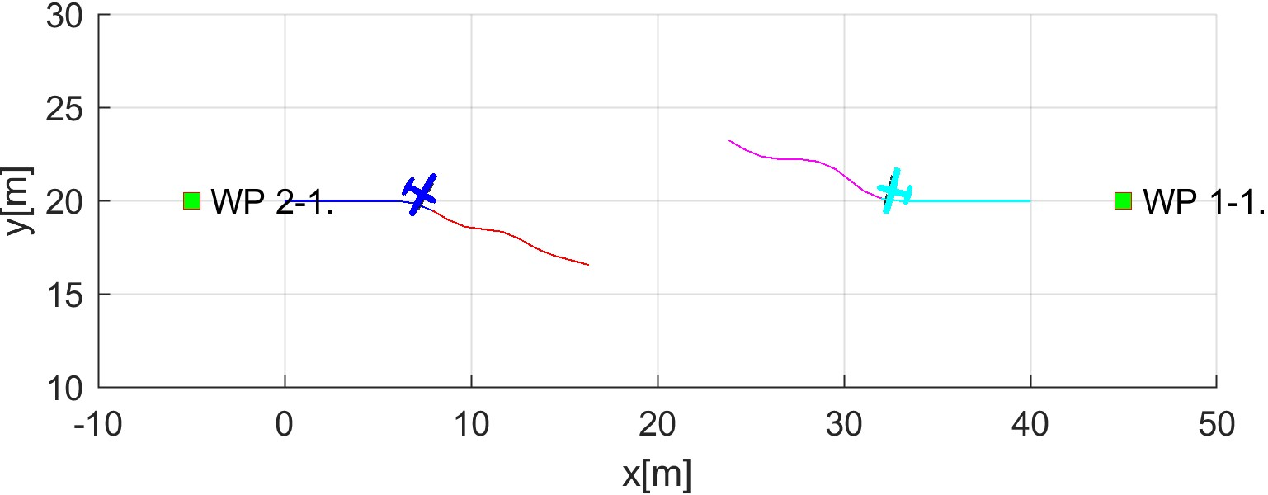

* + 1. Collision case creation.

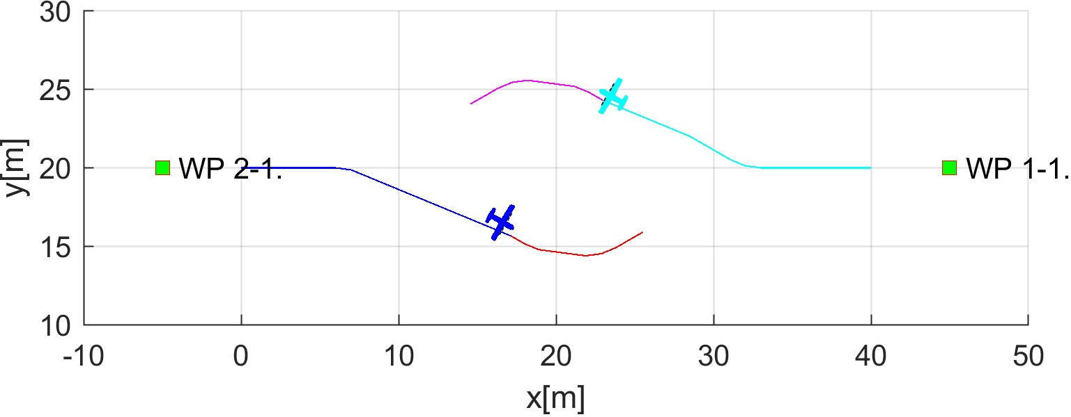

* + 1. Well clear before.

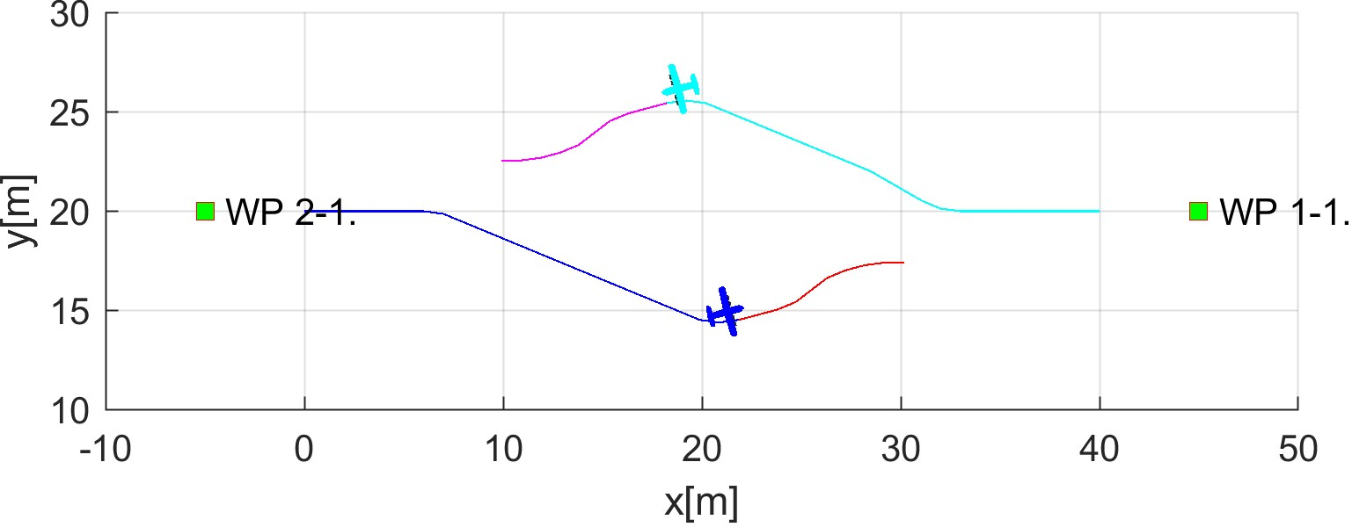

* + 1. Well clear after.

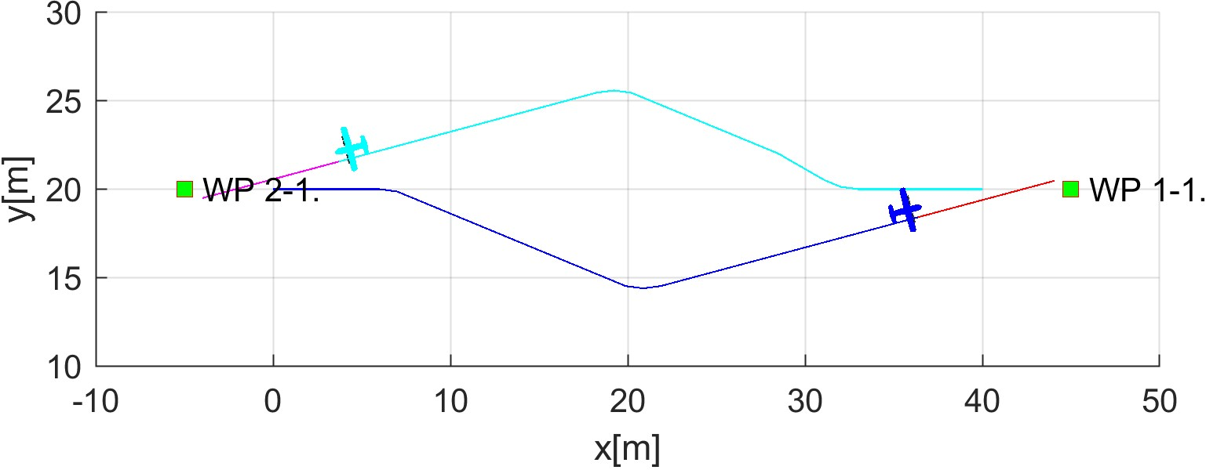

* + 1. Waypoints reach.

Figure 7.5: Test scenario for *Rule-based head-on approach* (virtual roundabout).

**Collision Case Calculation:** For test scenario in (fig. 7.5) where UAS 1 (blue) have head-on collision with UAS 2 (cyan), *Collision Case* have been calculated (tab. 7.6).

The *Collision point* is at [20*,*20*,*0]*T* in Flight Level *FL*450 coordinate frame.

The *angle of approach* was evaluated as 180◦ which indicates *Head on Approach* due to the 130◦ ≤ *angleofApproach* ≤ 180◦ conditions.

The *mutual position* of UAS 1 (blue) and UAS 2 (cyan) is giving the roles of *Roundabout* to *both* UAS.

The *safety margin* for *Well Clear* was determined as 5*m* for UAS 1 and UAS 2. The combined *Case Margin* is 10 m, which is sum of both. The *mutual distance* cannot go below this threshold.

|  |  |  |  |  |  |  |  |
| --- | --- | --- | --- | --- | --- | --- | --- |
|  |  | Collision Case | |  |  | Margins | |
| id | UAS | role | collision  point | angle of approach | type | safety | case |
| 1-2 | 1 | Roundabout | [20*,*20*,*0]*T* | 180◦ | Head on | 5 | 10 |
| 2 | Roundabout | 5 |

Table 7.6: Collision case for *Rule-based head-on* scenario.

**Distance to Safety Margin Evolution:** The safety margin values (well clear) (fig. 7.6) in controlled airspace are much larger than in non-controlled airspace (near miss) (fig. **??**).

The enforced rule was (rule **??**) with parameters: Collision Point [20*,*20*,*0]*T* and *Safety Margin* 10 *m* as given by Collision Case (tab. 7.6).

The mutual *UAS distance* (blue line) does not go over *Safety Margin* (red line) which means both UAS well clear margins are not broken by any means (fig. 7.5).

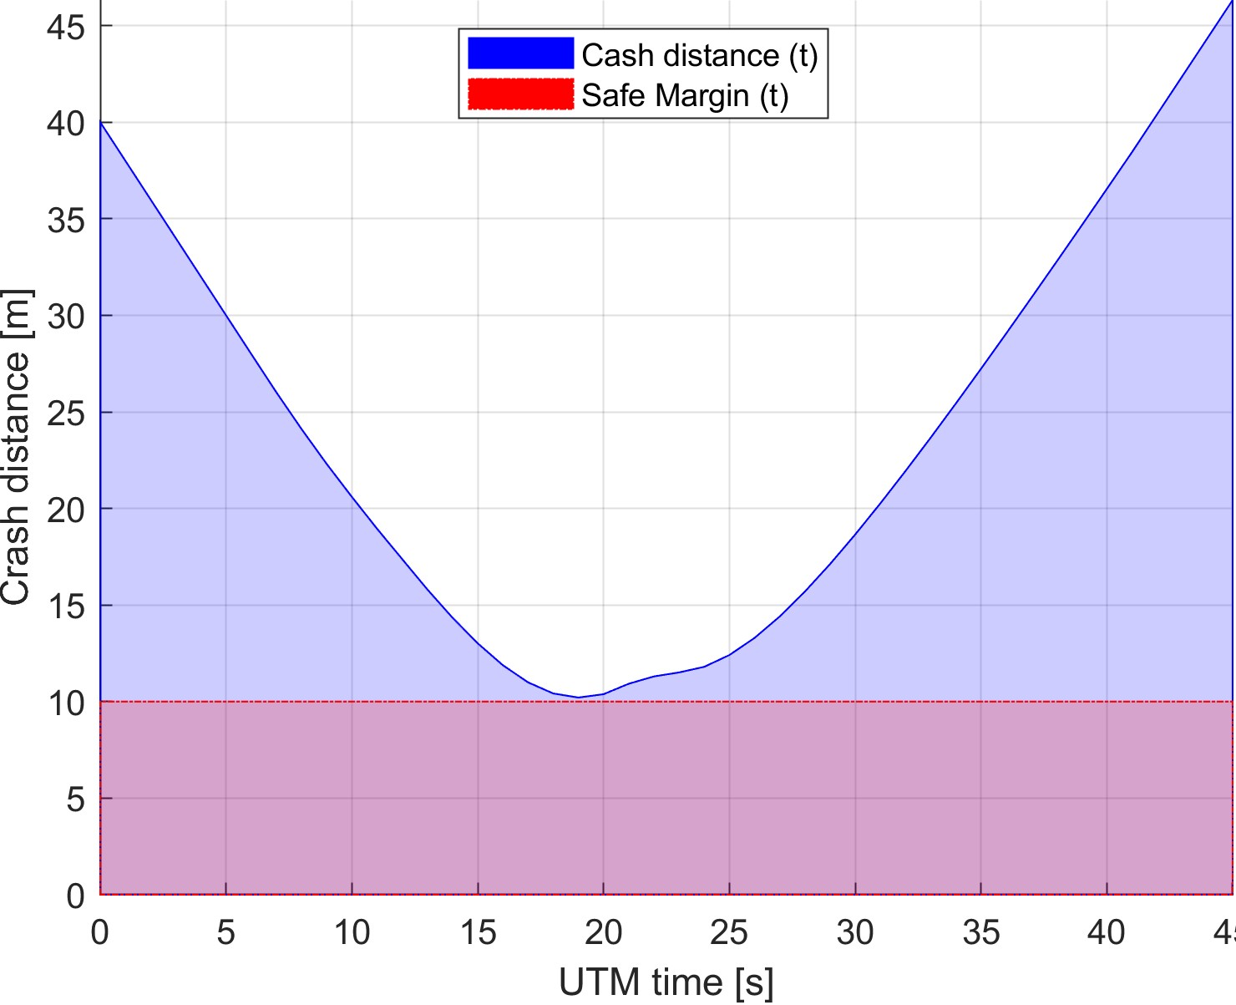

Figure 7.6: Distance to safety margin evolution for the *rule-based head-on scenario*.

**Distance to Safety Margin Peaks:** Given by (tab. 7.7) represents the proximity on UAS mutual distance to *well clear condition* breach. The breach of *well clear condition* was not achieved. The *minimal distance to the safety margin* was 0*.*2084 *m*. The *maximal distance to safety margin* was 36*.*3253*m* which represents distance at *Collision Case* closing.

|  |  |  |  |
| --- | --- | --- | --- |
|  | min | max | breach |

Distance to Safety Margin UAS:

1-2 0.2084 36.3253 false

Table 7.7: *Rule-based head on* safety margin distances.

**Path Tracking Performance:** *Path tracking* is displayed in (fig. 7.7). The *UAS* trajectory is divided into *X, Y, Z axis tracking over UTM Time*. The *Reference Trajectory* (green dashed line) interconnect starting position of UAS (green square marked S) a goal waypoint (green square marked 1). The *Executed Trajectory* (solid blue line) reflects real UAS trajectory.

1. UAS 1. (fig, 7.7a) do steady right side *roundabout maneuver* (y-axis).
2. UAS 2. (fig. 7.7b) do steady right side *roundabout maneuver* (y-axis).

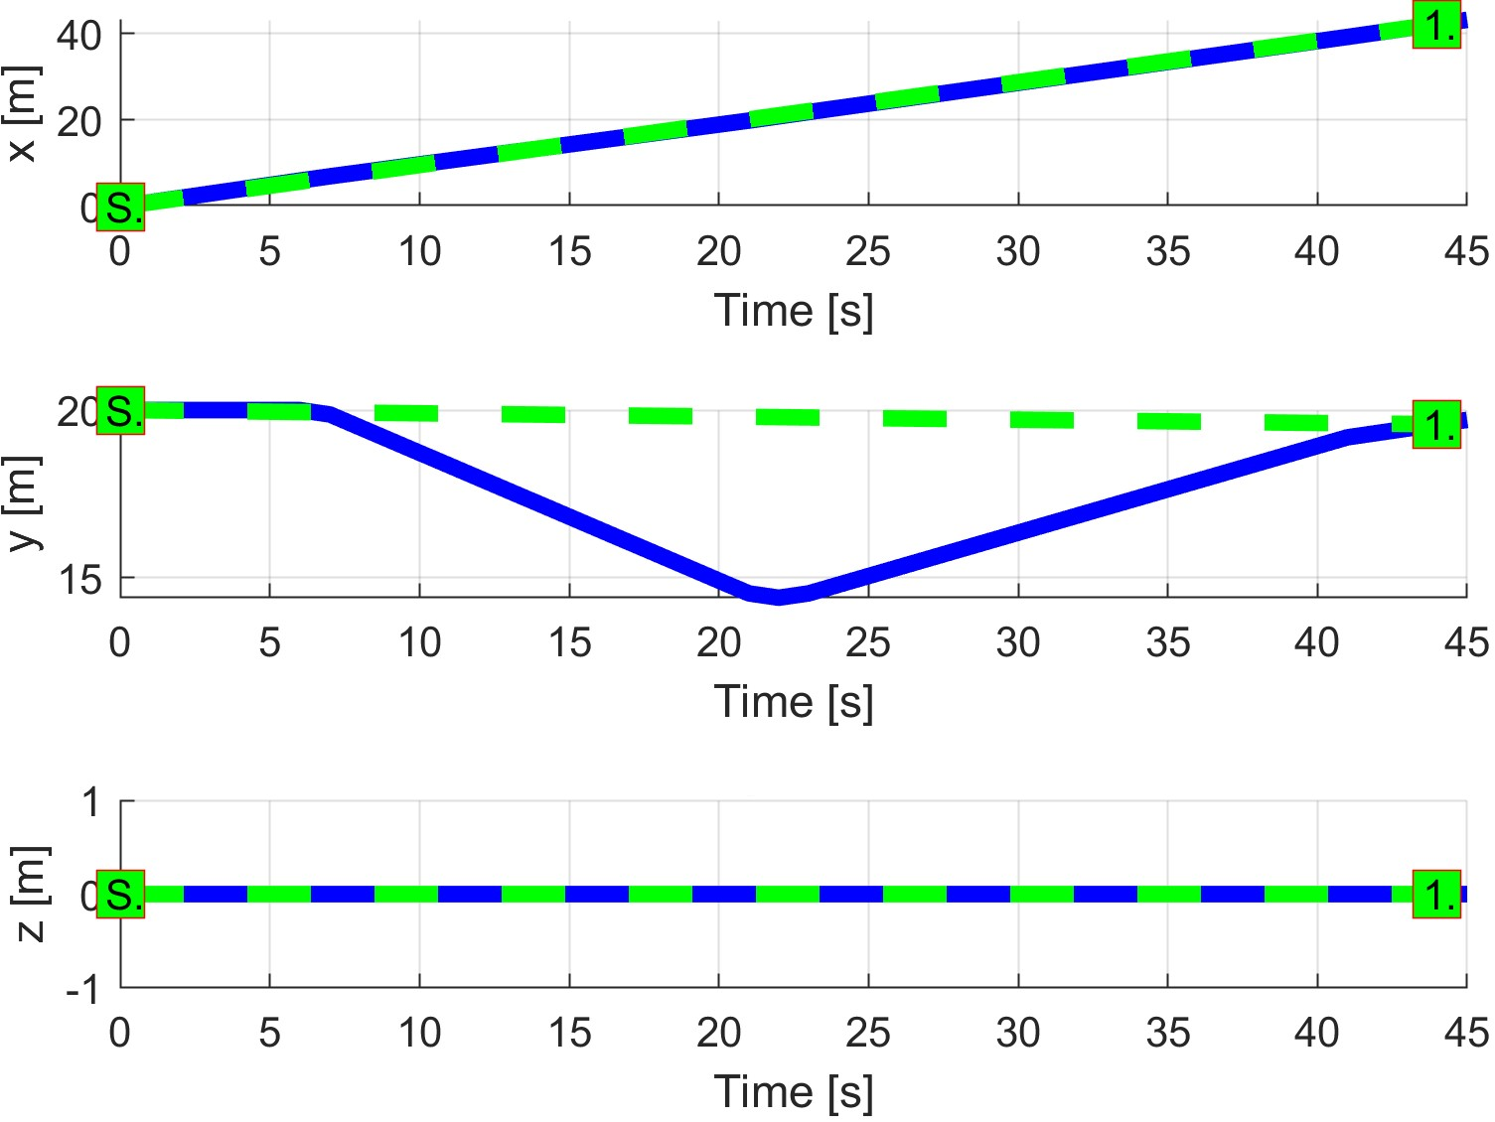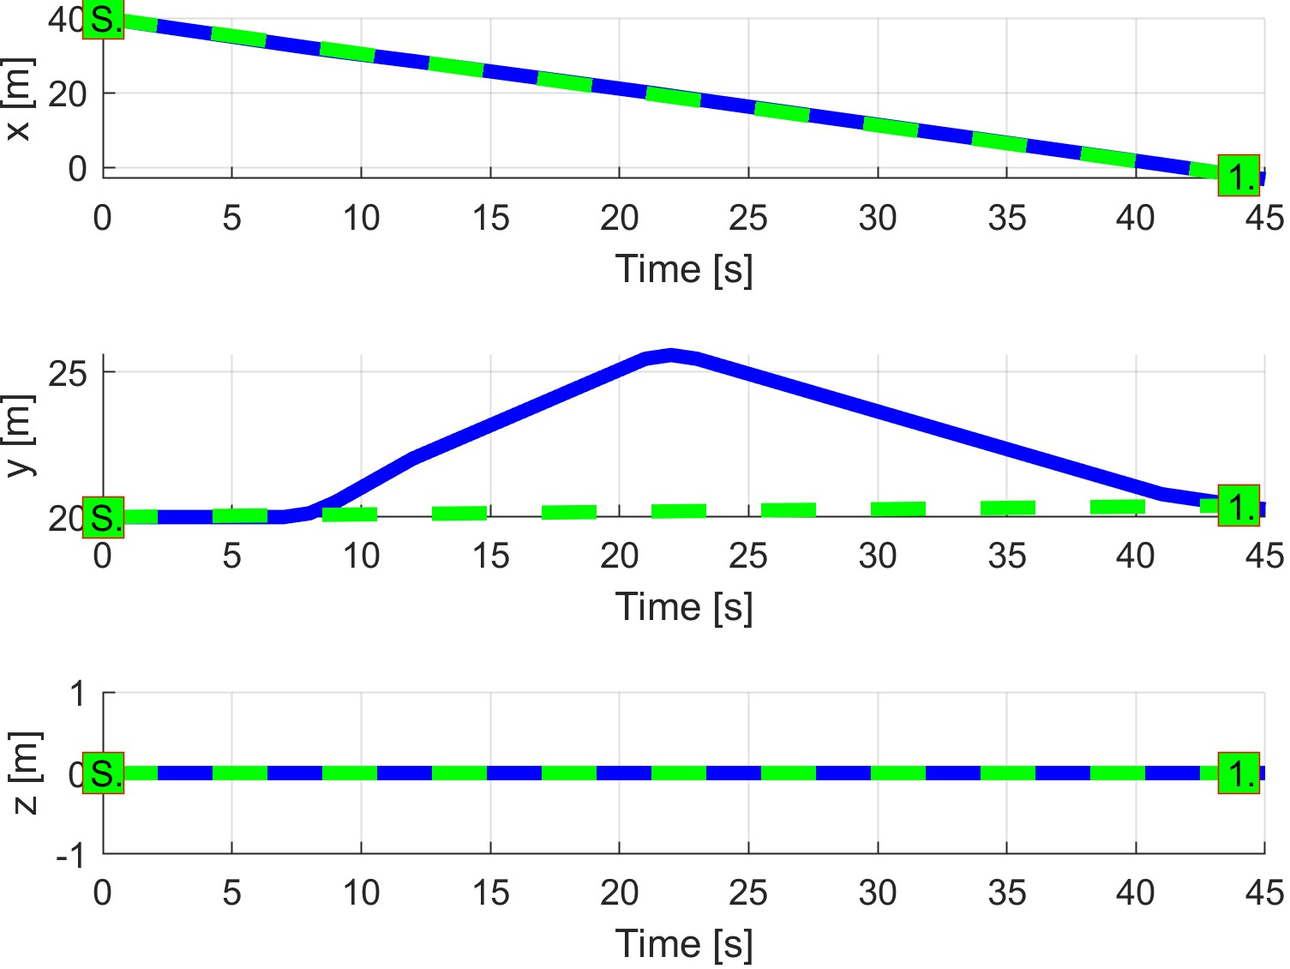

(a) UAS 1. (b) UAS 2.

Figure 7.7: *Trajectory tracking* for *Rule-based head-on* test case.

**Path Tracking Deviations:** Deviations (tab. 7.8) are in *expected ranges*, considering the *mission plans* (tab. 7.5) and *Collision Case* safety margin of 10*m*.

|  |  |  |
| --- | --- | --- |
| Param. | UAS 1 | UAS 2 |
| WP1 | WP1 |
| max|*x*| | 0 | 0 |
| max|*y*| | 5.40 | 5.40 |
| max|*z*| | 0 | 0 |
| max*dist.* | 5.40 | 5.40 |

Table 7.8: Path tracking properties for *Rule-based head-on* scenario.

**Computation Load:** The *computation load* for *scenario* (fig.7.8) shows used time (y-axis) over decision frame (x-axis).

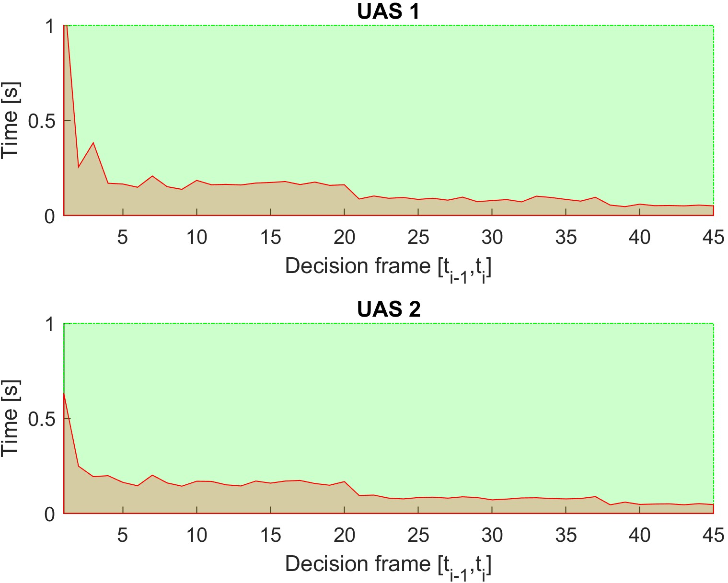

Figure 7.8: Computation time for *Rule-based head-on* scenario.

# 7.4.3 Rule-Based Mixed Head-On with Converging

**Scenario:** Four *UAS* are approaching an airway *intersection* at the *same time* from *opposite direction* in *controlled airspace* (over 500 feet Above Ground Level). Each *UAS* have following *Collision Hazards*:

1. *Head on Collision Hazard* - An UAS isapproaching from opposite direction which invokes need to avoid Collision Point actively.
2. *Active Converging Collision Hazard* - An UAS isapproaching from the *right side*, which gives him *Right of the Way* and invokes the need to avoid Intruder actively.
3. *Passive Converging Collision Hazard* - An UAS isapproaching from the *left side*, which gave us *Right of the Way* and imposes an obligation of *active avoidance* on other *UAS*.

*Note.* Presented scenario is *the worst possible situation* in current *manned aviation ATM*. *Mentioned Collision Hazards* must be addressed by *UTM* service in the following manner:

1. *Each UAS* in particular *Controlled Space* periodically sends synchronized *Position Notification* messages (tab. **??**).
2. *UTM* service receives *Position Notifications* and manages *Collision Cases* (tab.

**??**) in *Controlled Space*.

1. *UTM* detects multiple *Collision Cases* with *Collision Points* in the vicinity.
2. *UTM* service creates *Virtual Roundabout* and implements *Normative Directive* on all *UAS* in the area.

*Mission parameters* for four UAS systems are defined in (tab. 7.9).

|  |  |  |  |
| --- | --- | --- | --- |
| UAS | Position | | WP1 |
| [*x,y,z*] | [*θ,$,ψ*] |
| 1 | [0*,*20*,*0]*T* |  | [45*,*20*,*0]*T* |
| 2 | [40*,*20*,*0]*T* |  | [−5*,*20*,*0]*T* |
| 3 | [20*,*0*,*0]*T* |  | [20*,*45*,*0]*T* |
| 4 | [20*,*40*,*0]*T* |  | [45*,*20*,*0]*T* |

Table 7.9: Mission setup for *Rule-based mixed* scenario.

**Assumptions:** Following assumptions are valid for this test:

1. *Controlled Airspace Airworthiness* - UAS system is equipped with necessary controlled airspace equipment like ADS-B In/Out, Radar, Transponder, etc. Moreover, airworthy *UAS* can precisely follow *UTM directives* (max. 5 % deviation).
2. *C2 (Command & control) Link Established* - necessary for (UAS ↔ UAS) and (UAS ↔ UTM) communication. If *C2* link is lost the *UAS* will enter into *Emergency avoidance mode*.
3. *Decision frame synchronization with UTM* - necessary in discrete C2 environment otherwise *safety margins* needs to be *bloated*.
4. *Every UAS have identical cruising speed* - simplification impacting *UTM* service implementation. *Obstacle Avoidance Framework* can comprehend various intruders speed, with proper *UAS* directives.

**Main Goal:** Show possibility of *Virtual Roundabout* invoked by *UTM* directives where *Obstacle Avoidance Framework based on Reach Sets* is used as a *Navigation Module*.

**Acceptance Criteria:** Following criteria must be met:

1. *Well Clear Condition valid for every UAS* - Each *UAS* must have *minimal required distance* from *other UAS* for all *Virtual Roundabout* enforcement time.
2. *Fulfillment of UTM Directives* - Each UAS must stay in a *Navigation mode* for all *Virtual Roundabout* enforcement time. Each *UAS* must stay on *Virtual Roundabout* for the necessary time, before leaving for *Original Navigation waypoint* WP1.

**Testing Setup:** The *standard test setup* for each UAS defined in (tab. **??**, **??**, **??**, **??**, **??**) is used with following parameter override:

1. *Navigation grid - type* - *ACAS-like* with Horizontal enabled *maneuvers*

This *configuration* is based on the assumption that every UAS is in *controlled airspace* in *FL450* (flight level 45000 feet Above Sea Level), without permission for a *climb or descent maneuver*. *The rule engine* is initialized in standard *Rules of the air* configuration (fig. **??**).

There is *UTM* service for given *airspace cluster* calculating *collision cases* (tab. **??**) based on incoming *UAS position notifications* (tab. **??**).

**Simulation Run:** Notable moments from the *simulation run* (fig. 7.9) are the following:

1. *Collision cases created* (fig. 7.9a) following events happen in this step:
   1. Four *UAS* are approaching airways intersection: *UAS 1* (blue) from left, *UAS 2* (cyan) from right, *UAS 3* (green) from the bottom, *UAS 4* (black) from the top.
   2. They are going to collide at point [20*,*20*,*0]*T* of *Flight level* (elevation is 45, 000 feet Above Mean Sea Level).
   3. *UTM service* notices future *Collision Situations* and creates *Collision Cases*.
   4. There are many *Collision Cases* in the near vicinity. The *Virtual Roundabout* is created with *Safety margin* 15 *m*.
   5. The *UTM* service then sends a new *Roundabout Directives* to involved *UAS* systems.
   6. Each *UAS* starts *Roundabout Entry Maneuver* by correcting own *Heading* and *Speed* (if its necessary).
2. *Roundabout entry* (fig. 7.9b) - Each *UAS* enters into *Virtual Roundabout* while sending *Roundabout Entrance Notification* to *UTM service*.
3. *Roundabout leave* (fig. 7.9c) following events happens in this step:
   1. Each *UAS* when is going to approach the level of *Original Goal Waypoint* sends *Roundabout Leave Request*.
   2. UTM system will check if there is *Sufficient Free Space* to leave *Virtual Roundabout*.
   3. The *UTM Service then issues Virtual Roundabout Leave Approval*.
   4. Each *UAS* will correct own heading and speed in the range of received permit.
4. *Situation resolution* (fig. 7.9d) - Each *UAS* is heading away from *Roundabout*

*Center*, there is no active user of *Virtual Roundabout*. *UTM* will remove *Virtual Roundabout* and closes underlying *Collision Cases*. Each *UAS* will reach respective *Original Goal Waypoint*.

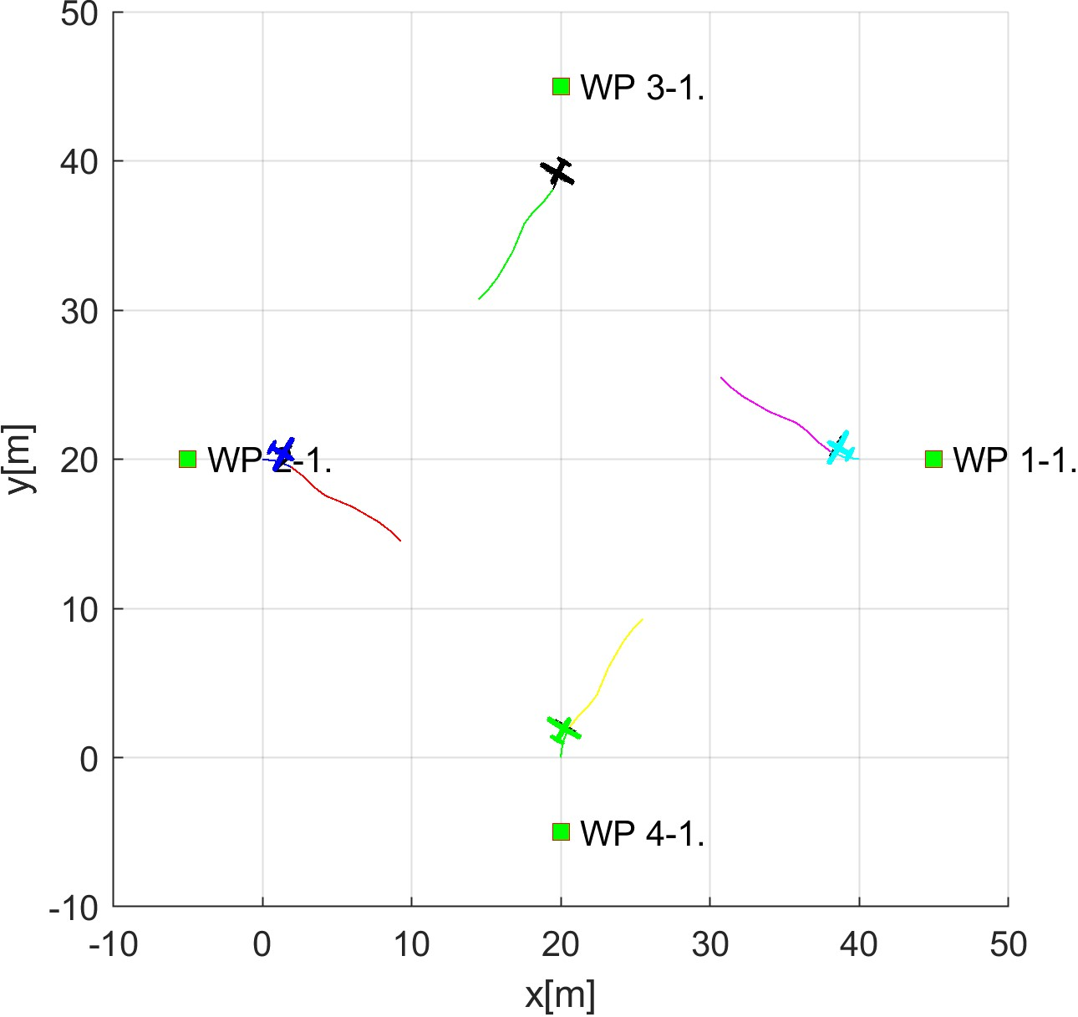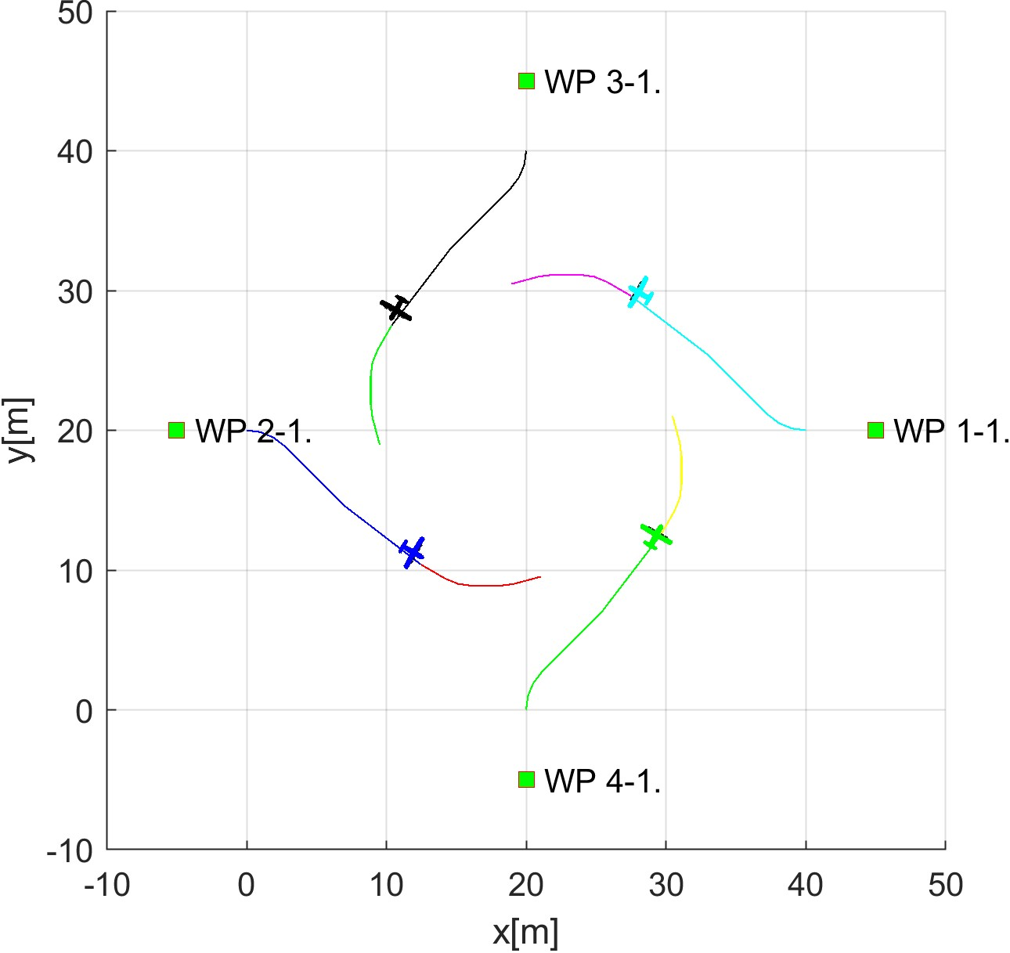

(a) Collision cases created. (b) Roundabout entry.

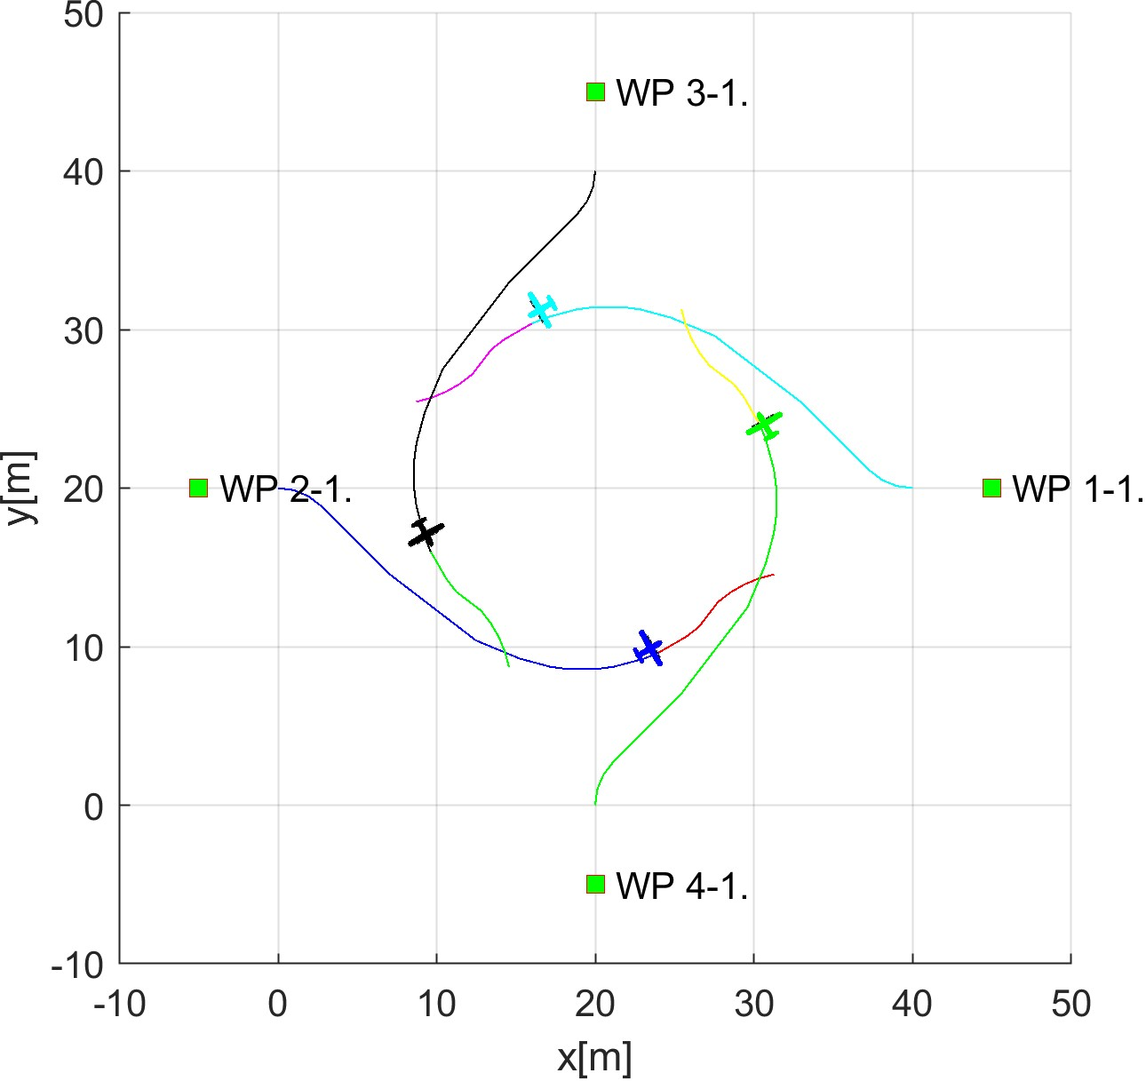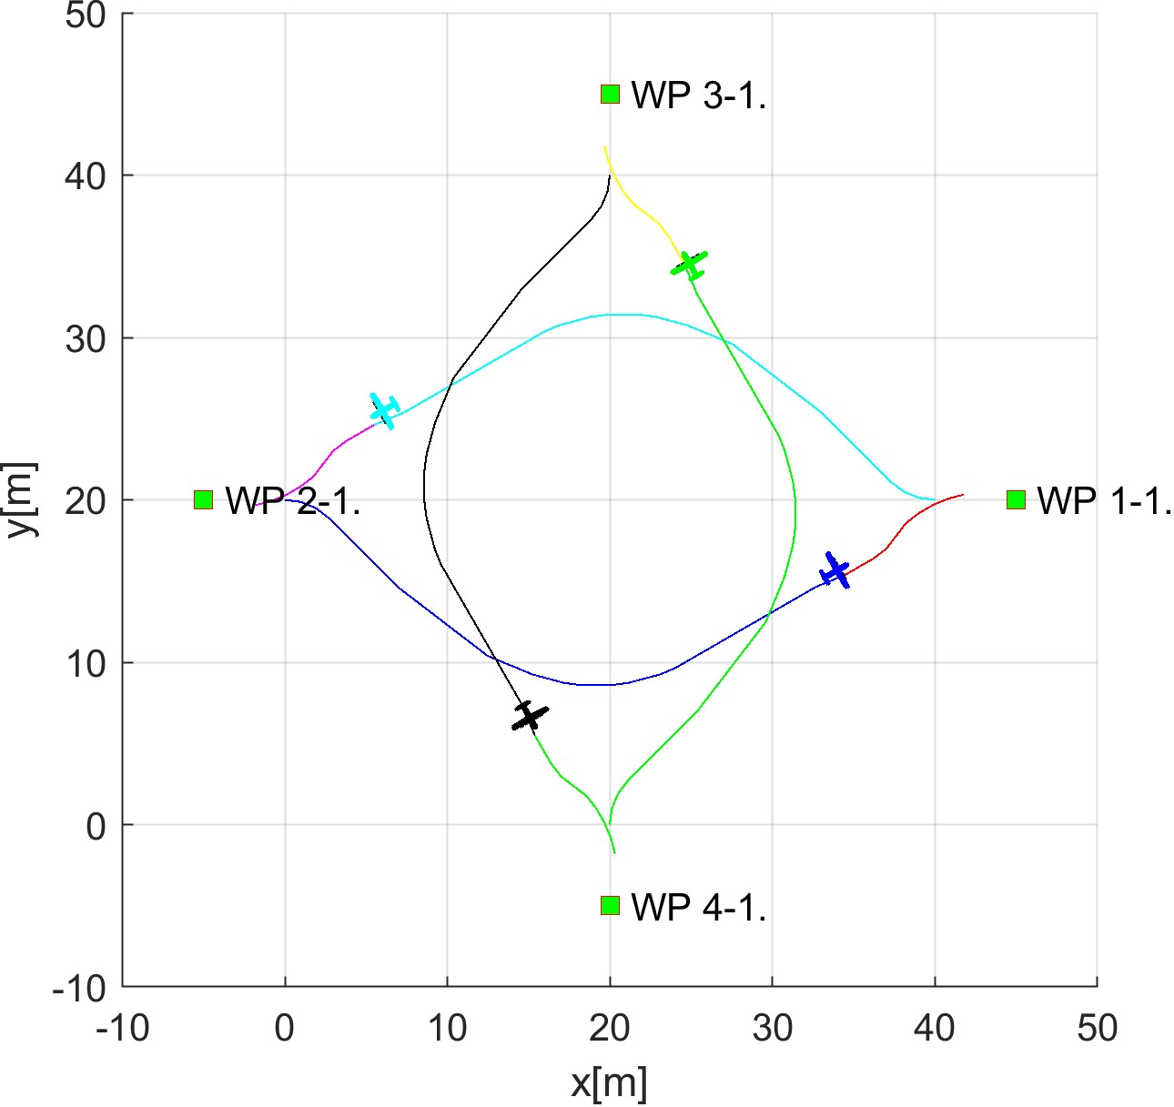

(c) Roundabout leave. (d) Situation resolution.

Figure 7.9: Test scenario for *Rule-based mixed* situation with the *self-separation mode*.

**Collision Cases Calculation:** The set of original *Collision cases* is given in (tab.

7.10).

Each *UAS* has one *Head on*, *Converging passive*, *Converging active* collision hazard. For example, *UAS 1* have a *head on* with *UAS 2*, *converging passive* with *UAS 4*, *converging active* with *UAS 3*. For *UAS 2-4* check *role* in respective *Collision Cases*.

*Note. Collision cases* calculated by *UTM* are symmetric, which means that collision case for *UAS X, UAS Y* is identical to collision case calculated for *UAS Y, UAS X*, *X* 6= *Y* .

*Safety margin* representing *Well Clear Margin* for single *UAS* in *Collision Case* ranges 5 − 8 *m*. *Case margin* representing the minimal mutual distance between two *UAS systems* to remain well clear ranges 12 − 15 *m*.

*Merged Collision Case* is oversimplified for demonstration purposes. *Merge Case*

*Procedure* is out of the scope of this work due to its extent. Every *Collision Case* shares same *Collision Point* [20*,*20*,*0]*T* in flight level coordinate frame. *Merged Collision Case* type was set as *Roundabout*, due the number of collision case *attendants* is greater than 2. Each *UAS role* has been set as *Roundabout*. The enforced *safety margin* is equal to 15 *m*, which is the maximum of all *single collision case combined margins*.

|  |  |  |  |  |  |  |  |
| --- | --- | --- | --- | --- | --- | --- | --- |
|  |  | Collision Case | |  |  | Margins | |
| id | UAS | role | collision  point | angle of approach | type | safety | case |
| 1-2 | 1 | Roundabout | [20*,*20*,*0]*T* | 180◦ | Head on | 8 | 15 |
| 2 | Roundabout | 7 |
| 1-3 | 1 | Converging | [20*,*20*,*0]*T* | 90◦ | Converging | 8 | 15 |
| 3 | Right o.W. | 5 |
| 1-4 | 1 | Right o.W. | [20*,*20*,*0]*T* | 90◦ | Converging | 8 | 15 |
| 4 | Converging | 5 |
| 2-3 | 2 | Right o.W. | [20*,*20*,*0]*T* | 90◦ | Converging | 7 | 12 |
| 3 | Converging | 5 |
| 2-4 | 2 | Converging | [20*,*20*,*0]*T* | 90◦ | Converging | 7 | 12 |
| 4 | Right o.W. | 5 |
| 3-4 | 3 | Roundabout | [20*,*20*,*0]*T* | 180◦ | Head on | 7 | 14 |
| 4 | Roundabout | 7 |
|  |  | Merged cases | | |  | Safety Margin | |
| id | UAS | role | collision point | | type |
| 1-2-  -3-4 | 1 | Roundabout | [20*,*20*,*0]*T* | | Roundabout | 15 | |
| 2 | Roundabout |
| 3 | Roundabout |
| 4 | Roundabout |

Table 7.10: Collision cases for *Rule-based mixed* scenario.

**Distance to Safety Margin Evolution:** *Merged Collision Case Safety Margin* is 15 *m,* and it is valid for all *UAS mutual distances*. The simple condition for *Remain Well Clear* is:

*crashDistance*(*UASX,UASY ,t*) ≥ 15*m,X* 6= *Y* ∈ {1*,*2*,*3*,*4}*,t* ∈ *utmTime*

*Safety Margin Performance* is given in (fig. 7.10). The mutual distance (Crash Distance [m]) between two UAS is denoted as the *blue line*. The enforced safety margin for *Remain Well Clear* condition is denoted as a red line.

*Note. Evolution of mutual crash distance* is symmetric. In any case, the mutual distance goes under *safety margin*. *Acceptance criterion* for *Well Clear condition* is fulfilled.

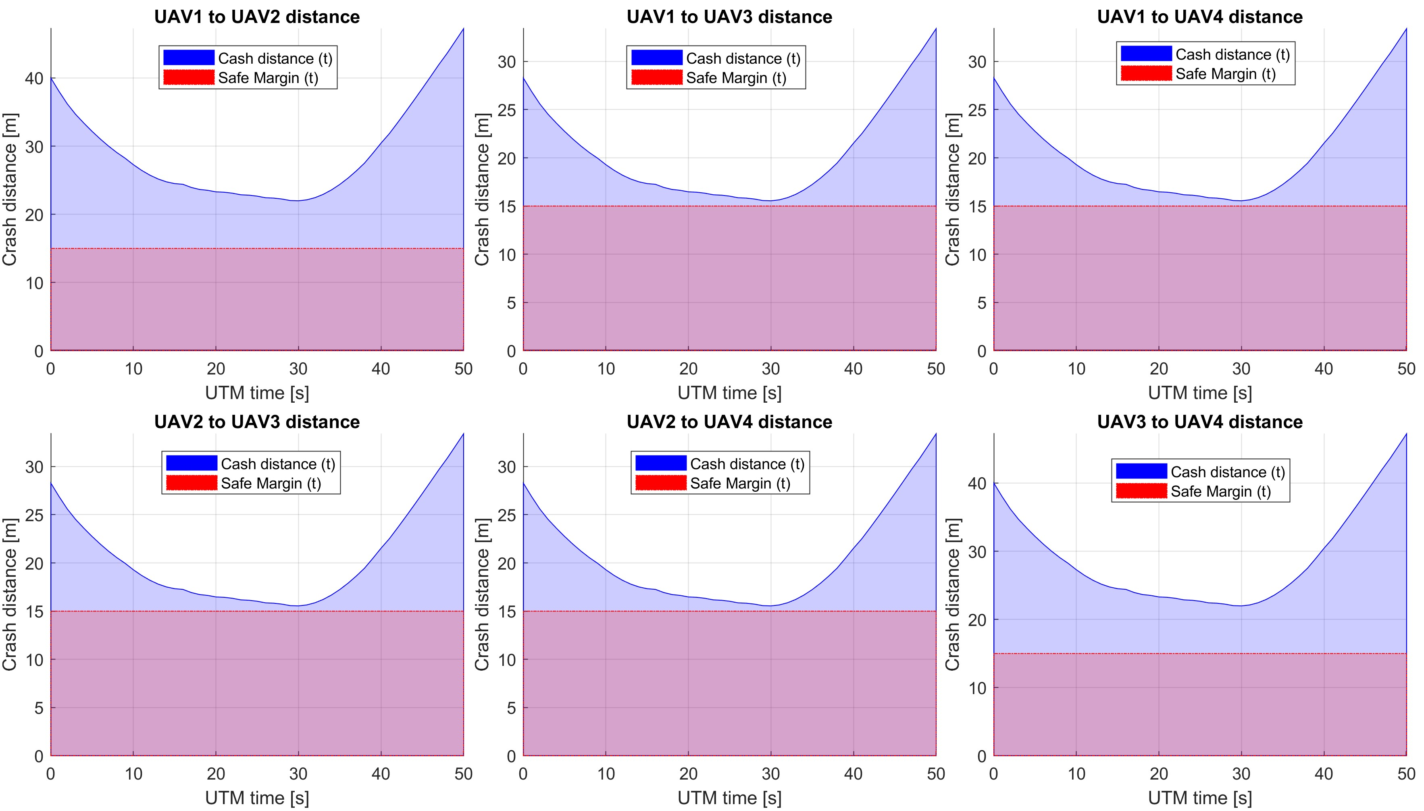

Figure 7.10: Distance to safety margin evolution for *rule-based mixed scenario*.

**Distance to Safety Margin Peaks:** *Distance to Safety Margin Peaks* (tab. 7.11) represents the proximity of *UAS mutual distance to breach well clear condition*. The *breach condition* was not fulfilled in any combination.

The *minimal distance to safety margin* was 0*.*5438 *m* between all four *UAS* systems. The *maximal distance to safety margin* ranges between *18 - 32 m* which show advantages of the *virtual roundabout*.

|  |  |  |  |
| --- | --- | --- | --- |
| UAS: | Distance to Safety Margin | | |
| min | max | breach |
| 1-2 | 6.9823 | 32.2369 | false |
| 1-3 | 0.5438 | 18.4015 | false |
| 1-4 | 0.5438 | 18.4015 | false |
| 2-3 | 0.5438 | 18.4015 | false |
| 2-4 | 0.5438 | 18.4015 | false |
| 3-4 | 6.9823 | 32.2369 | false |

Table 7.11: Distance to safety margin peaks for *rule-based mixed scenario*.

**Path Tracking Performance:** Path tracking is displayed in (fig. 7.11). The UAS trajectory is divided into *X, Y, Z axis tracking over UTM Time*. The *Reference Trajectory* (green dashed line) is represented as the interconnection between *Start Waypoint* (green square marked S) and *Goal Waypoint* WP1 (green square marked 1). The *Executed trajectory* (solid blue line) reflects real *UAS* movement.

1. *UAS 1* (fig. 7.11a) is using the bottom portion of *Virtual Roundabout* (-Y values), sticking to the boundary of the *Virtual Roundabout*.
2. *UAS 2* (fig. 7.11b) is using upper portion of the *Virtual Roundabout*. (+Y values), sticking to the boundary of the *Virtual Roundabout*.
3. *UAS 3* (fig. 7.11c) is using right portion of the *Virtual Roundabout*. (+X values), sticking to the boundary of the *Virtual Roundabout*.
4. *UAS 4* (fig. 7.11d) is using left portion of the *Virtual Roundabout*. (-X values), sticking to the boundary of the *Virtual Roundabout*.

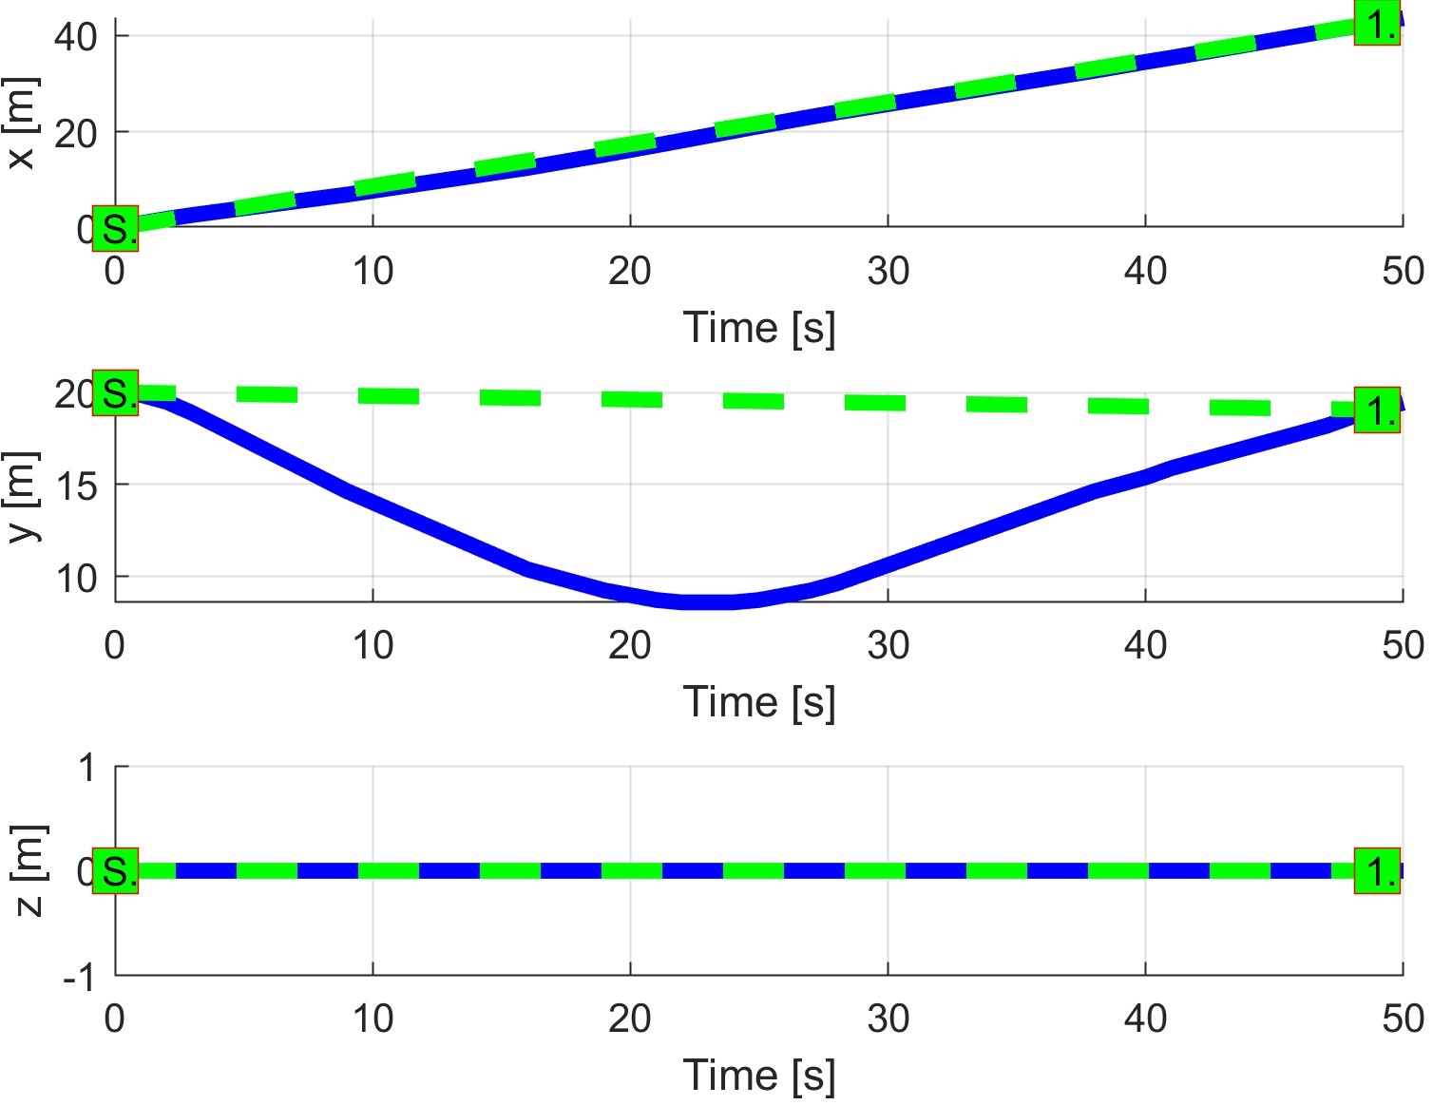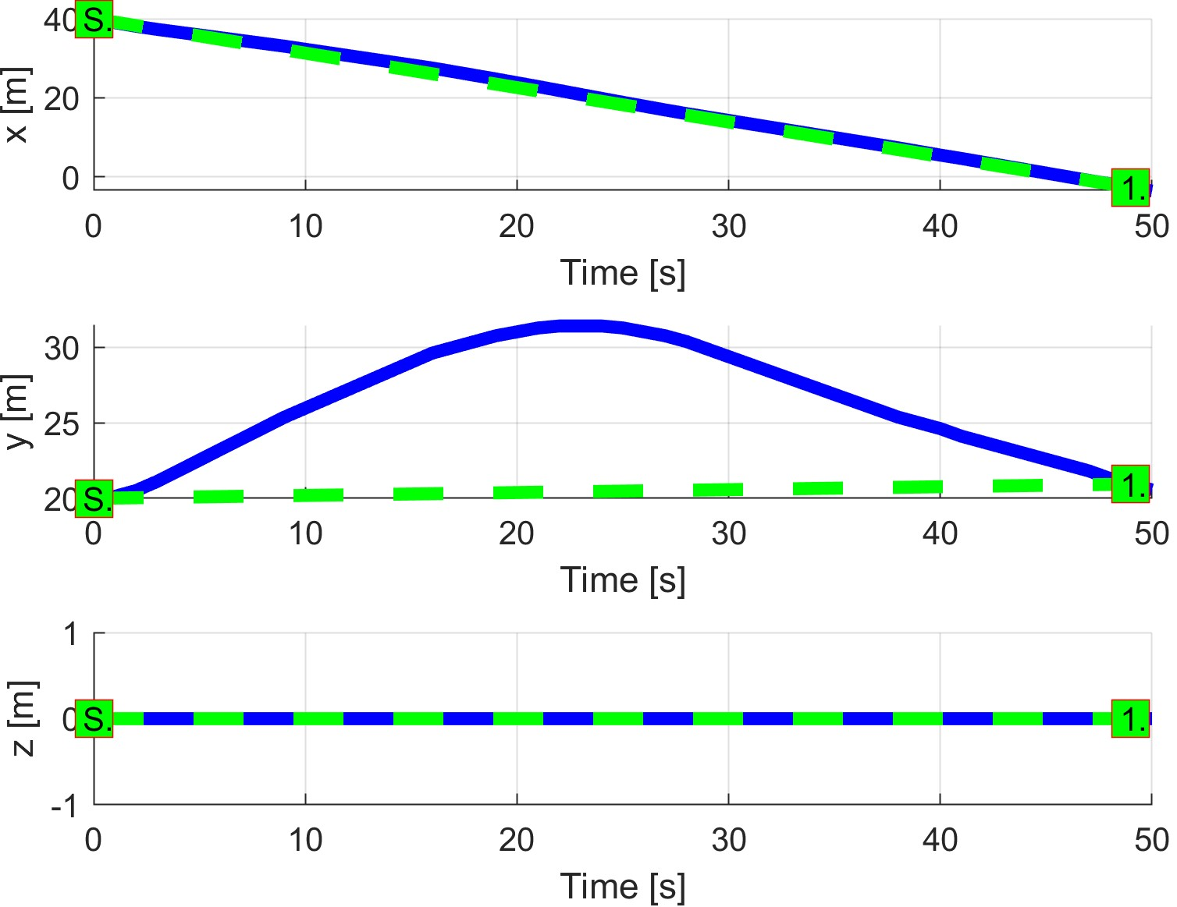

(a) UAS 1. (b) UAS 2.

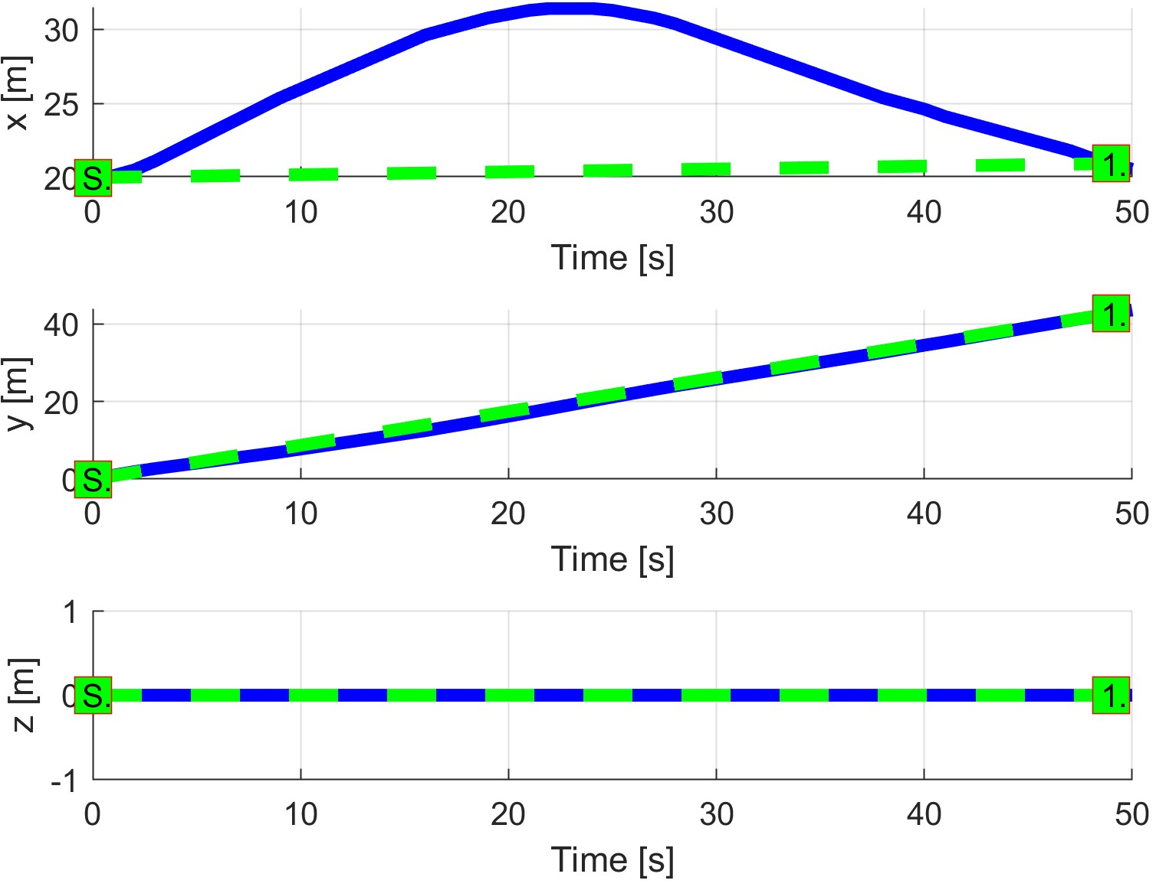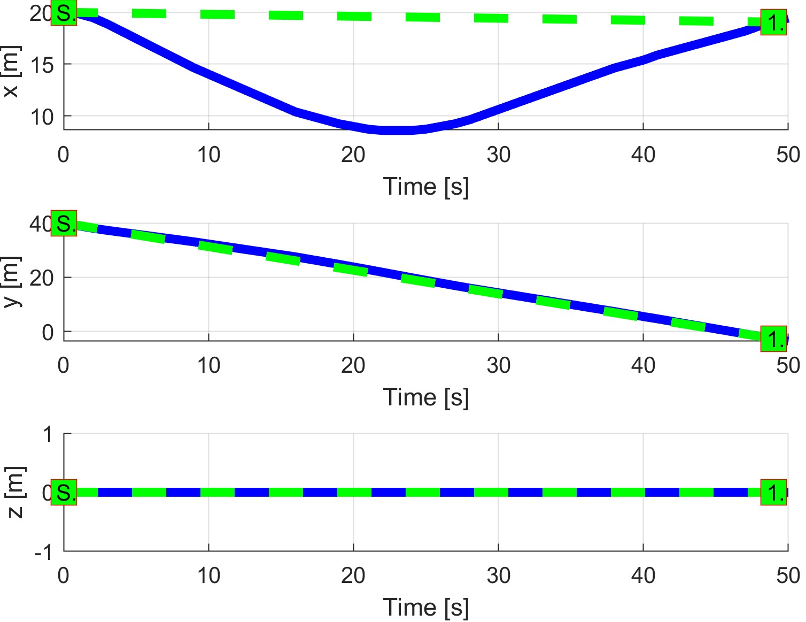

(c) UAS 3. (d) UAS 4.

Figure 7.11: Trajectory tracking for *Rule-based mixed* situation test case.

**Path Tracking Deviations:** *Deviations* (tab. 7.12) are in expected ranges, considering the mission plans (tab. 7.9) and *Merged Case Safety Margin* (15 *m*).

|  |  |  |  |  |
| --- | --- | --- | --- | --- |
| Param. | UAS 1 | UAS 2 | UAS 3 | UAS 4 |
| WP1 | WP1 | WP1 | WP1 |
| max|*x*| | 0 | 0 | 11.40 | 11.40 |
| max|*y*| | 11.40 | 11.40 | 0 | 0 |
| max|*z*| | 0 | 0 | 0 | 0 |
| max*dist.* | 11.40 | 11.40 | 11.40 | 11.40 |

Table 7.12: Path tracking properties for *Rule-based mixed* scenario.

**Computation Load:** The *computation load* for *scenario* (fig.7.12) shows used time (y-axis) over decision frame (x-axis).

The *computation time* for each UAS has the same evolution. The *load* is higher during avoidance maneuver on the *virtual roundabout*.

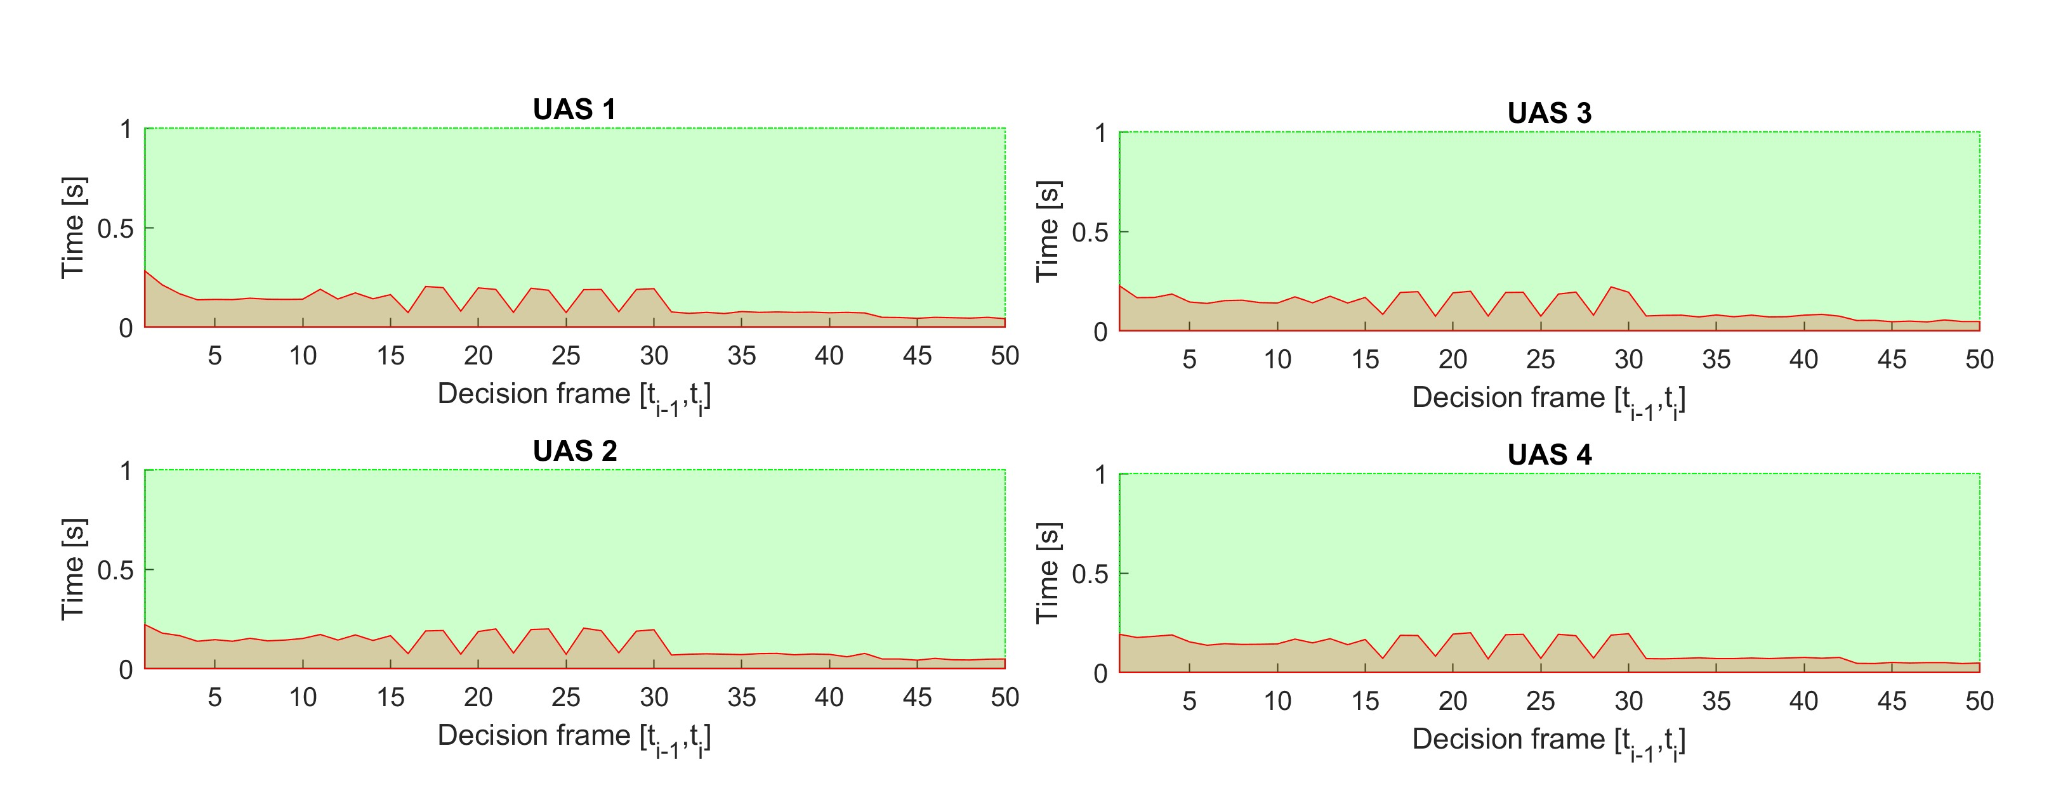

Figure 7.12: Computation time for *Rule-based multiple* scenario.

# 7.4.4 Rule-Based Overtake

**Scenario:** Two UAS are flying in the *controlled airspace* (over 500 feet Above Ground Level) on the *airway* (in the same direction). *Slower UAS* is in front of *Faster UAS*. There is possibility of a *collision* or a *near miss incident* or a *well clear breach*. The *Faster UAS* (Overtaking) must contact *UTM* service and ask for *overtake permission*. Scenario steps:

1. *Faster UAS* (Overtaking) notices *UTM* service about *Slower UAS* (Overtaken). (This step is Optional.)
2. *UTM* service issues *Directives* to all *UAS* in the area.
3. *Overtake Directive* is received by *Faster UAS* (Overtaking) and *Slower UAS* (Overtaken).
4. *Faster UAS* (Overtaking) mission plan is altered to reflect *Overtake directive*, *Divergence Waypoint* and *Convergence Waypoint* are added.
5. *Faster UAS* (Overtaking) safely overtakes *Slower UAS* (Overtaken) without breaking *Well clear* condition.

*Mission parameters* for both *UAS* systems are defined in (tab. 7.13).

Position

|  |  |  |  |
| --- | --- | --- | --- |
|  | [*x,y,z*] | [*θ,$,ψ*] | 1 |
| 1 | [−40*,*20*,*0]*T* |  | [110*,*20*,*0]*T* |

UAS WP

2 [−20*,*20*,*0]*T* [0◦*,*0◦*,*0◦]*T* [80*,*20*,*0]*T*

Table 7.13: Mission setup for all *Rule based overtake* scenarios.

**Assumptions:** Following assumptions are valid for this test:

1. *Controlled Airspace Airworthiness* - UAS system is equipped with necessary controlled airspace equipment like ADS-B In/Out, Radar, Transponder, etc. Moreover, airworthy *UAS* has capability to precisely follow *UTM directives* (max. 5 % deviation).
2. *C2 (Command & control) Link Established* - necessary for (UAS ↔ UAS) and (UAS ↔ UTM) communication. If *C2* link is lost the *UAS* will enter into *Emergency avoidance mode*.
3. *Decision frame synchronization with UTM* - necessary in discrete C2 environment otherwise *safety margins* needs to be *bloated*.

**Main Goal:** Show possibility of *Overtake Maneuver* invoked by the *UTM Directive*

(event-based flight constraint).

**Acceptance Criteria:** Following criteria must be met:

1. *Proper passing of Divergence/Convergence Waypoint* - a minimal distance of *UAS trajectory* to *Divergence/Convergence waypoint* must be below the passing threshold. Waypoints need to be passed in given order (Divergence 1*st*, Convergence 2*nd*).
2. *Slower UAS (Overtaken) keeps Right of the Way* - the UAS with lesser maneuverability does not stand a chance in avoidance situation, it needs to keep its *Right of the Way*.
3. *Both UAS does not breach Well Clear (safety) Margin* - mutual distance does not get through *calculated Safety Margin*.

**Testing Setup:** The *standard test setup* for each UAS defined in (tab. **??**, **??**, **??**, **??**, **??**) is used with following parameter override:

1. *Navigation grid - type* - *ACAS-like* with Horizontal enabled *maneuvers*

This *configuration* is based on the assumption that every UAS is in *controlled airspace* in *FL450* (flight level 45000 feet Above Sea Level), without permission for a *climb or descent maneuver*. *The rule engine* is initialized in standard *Rules of the air* configuration (fig. **??**).

There is *UTM* service for given *airspace cluster* calculating *collision cases* (tab. **??**) based on incoming *UAS position notifications* (tab. **??**).

**Simulation Run:** Notable moments from the *simulation run* (fig. 7.13) are the following:

1. *Collision case creation* (fig.7.13a) - *Faster UAS* (blue) receives *UTM Directive* to invoke *Overtake Rule* (tab. **??**). *Slower UAS* (magenta) receives *UTM Directive* to keep *Right of the Way* and warning that is going to be *Overtaken*. *Faster UAS* (blue) creates two *virtual waypoints*:

1. *Divergence waypoint* at position [0*,*14*,*0]*T*.
2. *Convergence waypoint* at position [24*,*14*,*0]*T*.

*Faster UAS* then sets *Divergence waypoint* as *Goal waypoint,* and It starts to overtake maneuver while checking mutual distance.

1. *Divergence waypoint reach* (fig. 7.13b) - *Faster UAS* (blue) successfully reached *Divergence Waypoint*, setting *Convergence Waypoint* as new *Goal waypoint*.
2. *Convergence waypoint reach* (fig. 7.13c) - *Faster UAS* (blue) successfully reached *Convergence Waypoint*, setting *Original Goal Waypoint* as new *Goal waypoint*. The *UTM* service is notified from *Faster UAS* (blue) that *Overtaken Maneuver* has been completed. UTM *acknowledges* maneuver competition and It sends a notification to *Slower UAS* (magenta) that *Overtake Maneuver* is finished. *Slower UAS* (magenta) was successfully overtaken.
3. *Original waypoint reach* (fig. 7.13d) - *Faster UAS* (blue) successfully reached *Original Waypoint*, Starting landing Sequence.

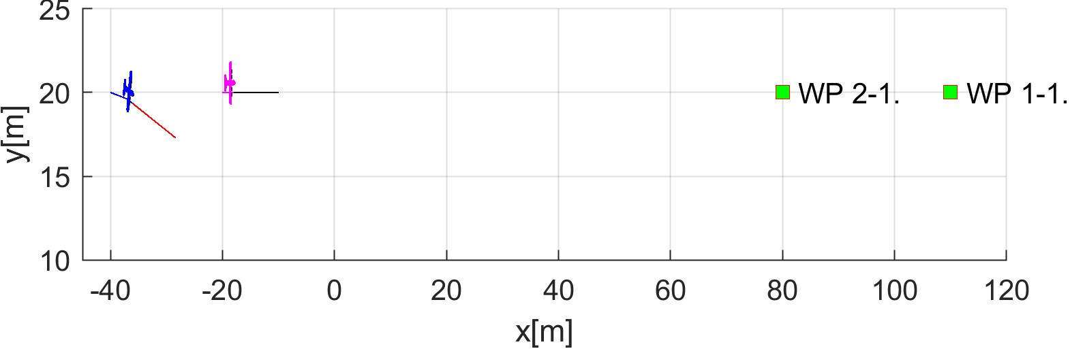

* 1. Collision case creation.

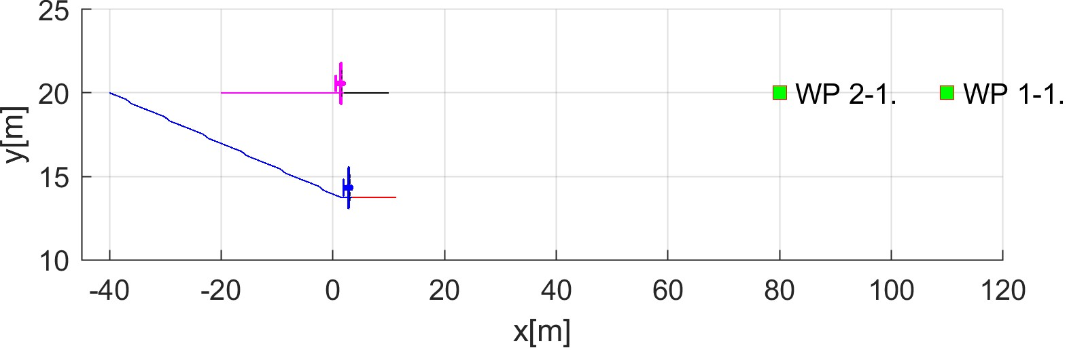

* 1. Divergence waypoint reach.

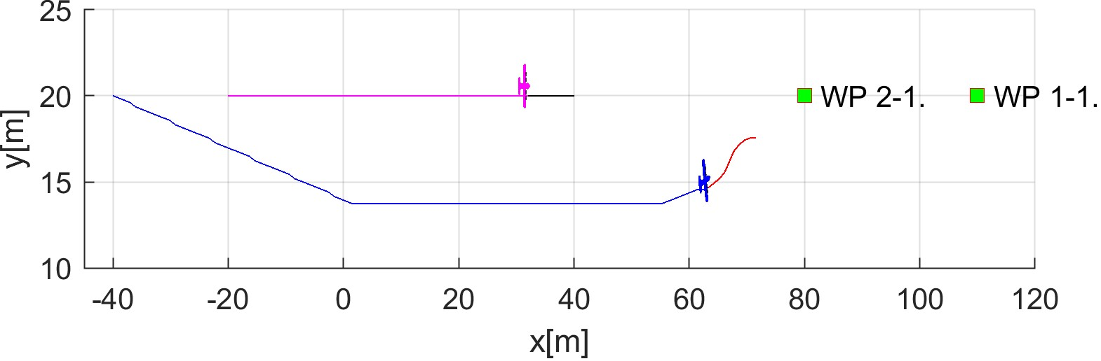

* 1. Convergence waypoint reach.

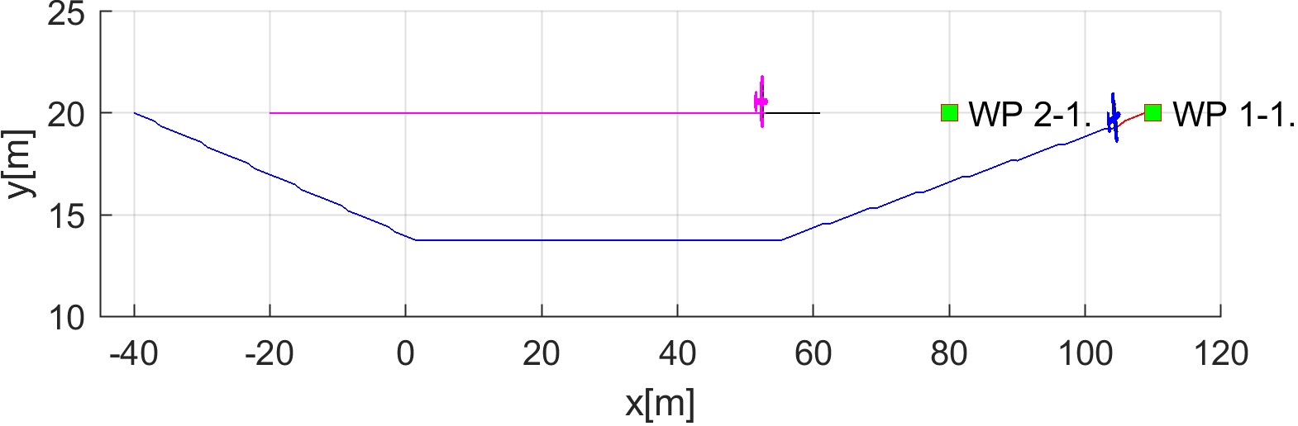

* 1. Original waypoint reach.

Figure 7.13: Test scenario for *Rule-based Overtake* (double speed of overtaking aircraft).

**Collision Case Calculation:** The *Collision Case* (tab. 7.14) was calculated according to the *Collision Calculation process* (sec. **??**). *Faster UAS* (1) has *Overtaking* role, and *Slower UAS* has *the right of way*. *Collision Point* is direct type at [0*.*20*.*0]*T*. *Collision case type* was set based on *angle of approach* 0◦ as *Overtake*. The *Safety Margin* was set as *5 m*.

|  |  |  |  |  |  |  |  |
| --- | --- | --- | --- | --- | --- | --- | --- |
|  |  | Collision Case | |  |  | Margins | |
| id | UAS | role | collision  point | angle of approach | type | safety | case |
| 1-2 | 1 | Overtaking | [0*,*20*,*0]*T* | 0◦ | Overtake | 5 | 5 |
| 2 | Right o.W. | 5 |

Table 7.14: Collision case for *Rule-based Overtake* scenario 2x speed.

**Overtake Speed: Divergence/Convergence Waypoints** *Divergence waypoints* have been calculated according to (eq. **??**), and, *Convergence Waypoints* have been calculated according to (eq. **??**). Following *Speed Differences* were taken into account (Faster/Slower UAS speed ratio): *2x, 3x, 4x*. Following observations can be made:

1. *The distance between Divergence and Convergence waypoint* is decreasing with increasing *speed difference*.
2. *Divergence waypoint* is moving *back/right* in *UAS Local Coordinate Frame* with Increasing *speed difference*.
3. *Convergence waypoint* is moving like *Divergence waypoint* but a little bit faster.

|  |  |  |  |  |  |
| --- | --- | --- | --- | --- | --- |
| Speed diff. | Divergence | | Convergence | | Final waypoint |
| waypoint | difference | waypoint | difference |
|  |  |  |  |
| 2x | [0*,*14*,*0]*T* |  | [24*,*14*,*0]*T* |  | [110*,*20*,*0]*T* |
|  |  |
|  |  | [−10*,*−1*,*0]*T* |  | [−8*,*−1*,*0]*T* |  |
|  |  |  |  |
| 3x | [−10*,*13*,*0]*T* |  | [16*,*13*,*0]*T* |  | [110*,*20*,*0]*T* |
|  |  |
|  |  | [−3*.*4*,*−1*,*0]*T* |  | [−1*.*3*,*−1*,*0]*T* |  |
|  |  |  |  |
| 4x | [−13*.*4*,*12*,*0]*T* |  | [14*.*7*,*12*,*0]*T* |  | [110*,*20*,*0]*T* |
|  |  |

Table 7.15: Convergence and divergence waypoints for various speed differences.

**Overtake Speed: Impact on Trajectory** Overtake *speed difference* is visible in (fig. 7.14). The *Slower vehicle trajectory*(cyan) is following *standard mission waypoints*. The *Faster vehicle trajectory* for 2x (blue), 3x (green), 4x (black) are following *Divergence/Convergence* waypoints from (tab. 7.15).

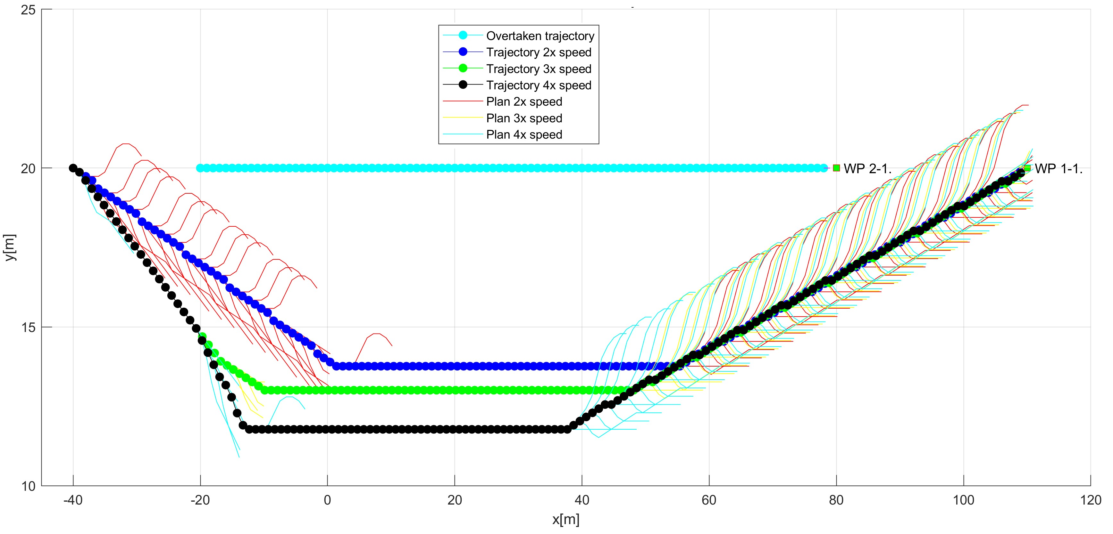

Figure 7.14: *Rule-based overtake* trajectories at a different speed.

**Overtake Speed: Impact on Distance to Safety Margin Evolution** *Safety margin* (red line) is set to *5 m*. It is obvious that *Faster UAS* will take down *Slower UAS* if there was not for an *Overtake maneuver*. The distance of *Faster UAS* to *Slower UAS* evolution is depending on *Speed difference*. *Inflection point* (closest point of two UAS) is reached sooner with *Higher speed*. *Safety margin performance* was measured for the *UTM performance time* in the interval [0*,*35] *s* and *Speed difference* of 2x (blue), 3x (green), 4x (black).

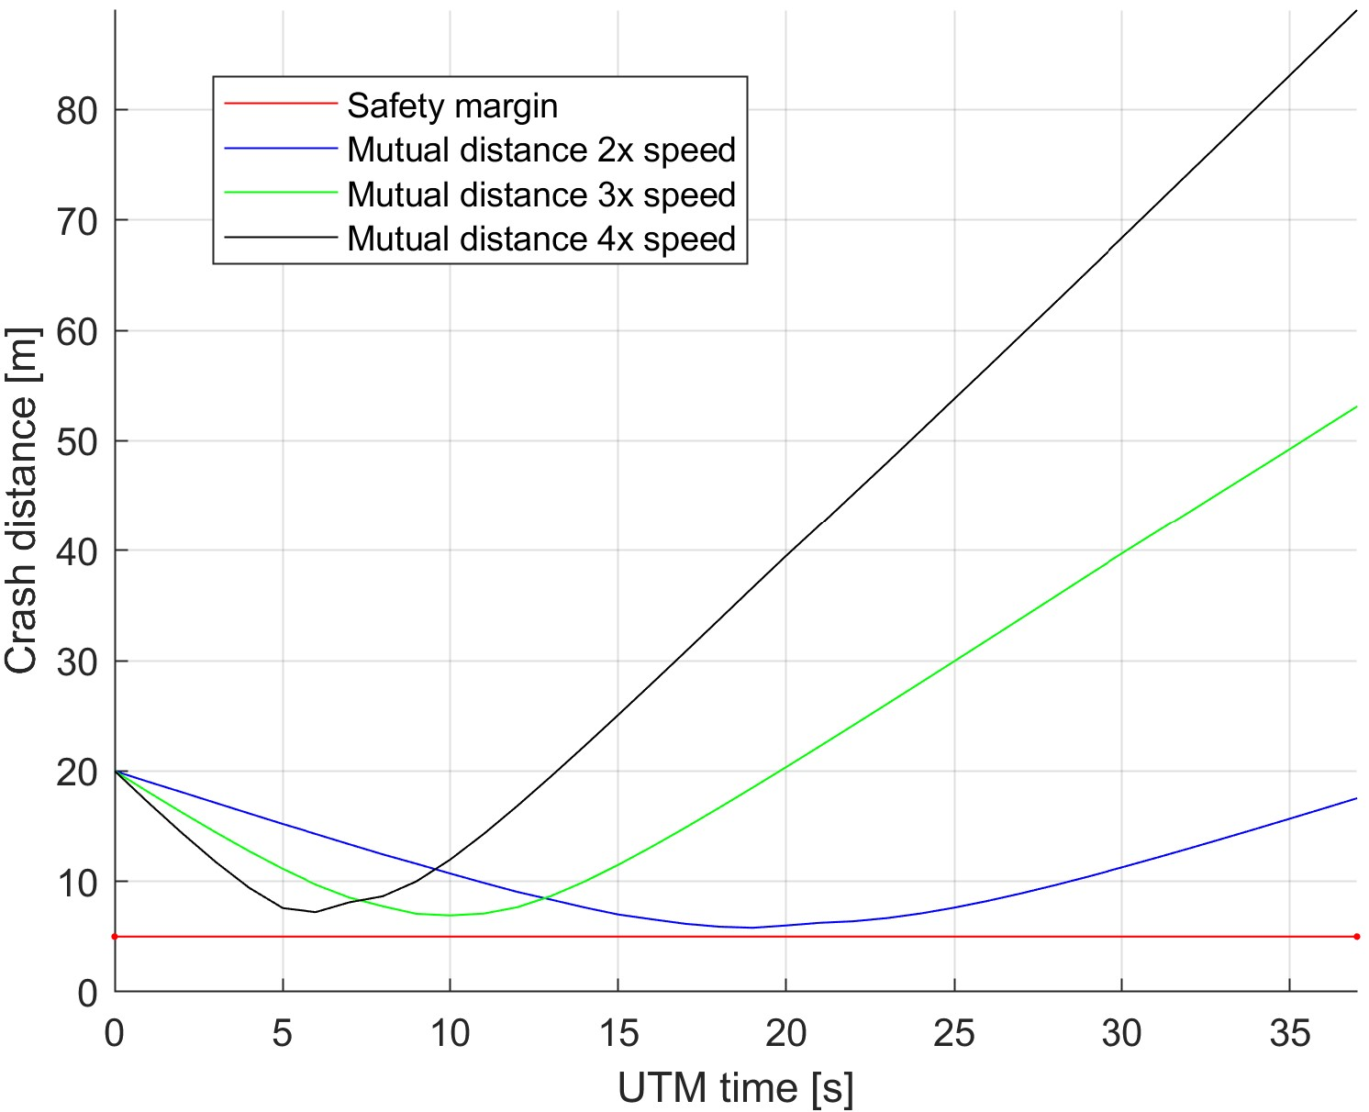

Figure 7.15: Overtake speed-dependent distance to safety margin evolution for *rule-based overtake scenario*.

**Overtake Speed: Impact on Distance to Safety Margin Peaks** There is summary table (tab. 7.16) for measurement of minimal and maximal values for *Distance to Safety Margin* over *UTM time* (fig.7.15). The minimal *Overtake Distance to Safety Margin* in

0*.*7991 *m* for 2x *Speed Difference*. The minimal *Overtake closest point reach time* is 7 *s* for 4x *Speed Difference*.

For each *Speed difference* (2x, 3x, 4x), the *Well Clear Margin* (Safety Margin) was not reached by the *Faster UAS Body boundary*.

|  |  |  |  |  |  |
| --- | --- | --- | --- | --- | --- |
| Speed diff. | Minimal | | Maximal | | Breach |
| distance | time | distance | time |
| 2x | 0.7991 | 20 | 48.8508 | 76 | false |
| 3x | 1.9180 | 11 | 73.5336 | 51 | false |
| 4x | 2.2154 | 7 | 84.0721 | 38 | false |

Table 7.16: Distance to safety margin peaks for various overtake speed in *Rule-based overtake scenario*.

**Path Tracking Performance: 2x Speed** Performance was only evaluated for the case when *Faster/Slower UAS speed ratio* is 2*x*. All waypoints are marked as green numbered *squares* with a number. Initial waypoint is marked as a green square with *S*. Reference trajectory is annotated as *green dashed line*. *The executed trajectory is annotated* as *blue solid line*.

Following observations can be made from path tracking (fig. 7.16):

1. *UAS 2 has the right of way* (fig. 7.16b) - *reference trajectory* and *executed trajectory* are identical.
2. *UAS 1 is Overtaking* (fig. 7.16a) - the following waypoints are marked on reference trajectory:
   1. *Collision Point* (WP 1.) - this is not used for navigation, it is marking of *Collision Point*.
   2. *Divergence waypoint* (WP 2.) - there will *Faster UAS* navigate to avoid *Collision*.
   3. *Convergence waypoint* (WP 3.) - there will *Faster UAS* navigate to gain *Safe Return Distance*.
   4. *Original Goal Waypoint* (WP 4.) - there will *Faster UAS* continue until *original goal* is reached.

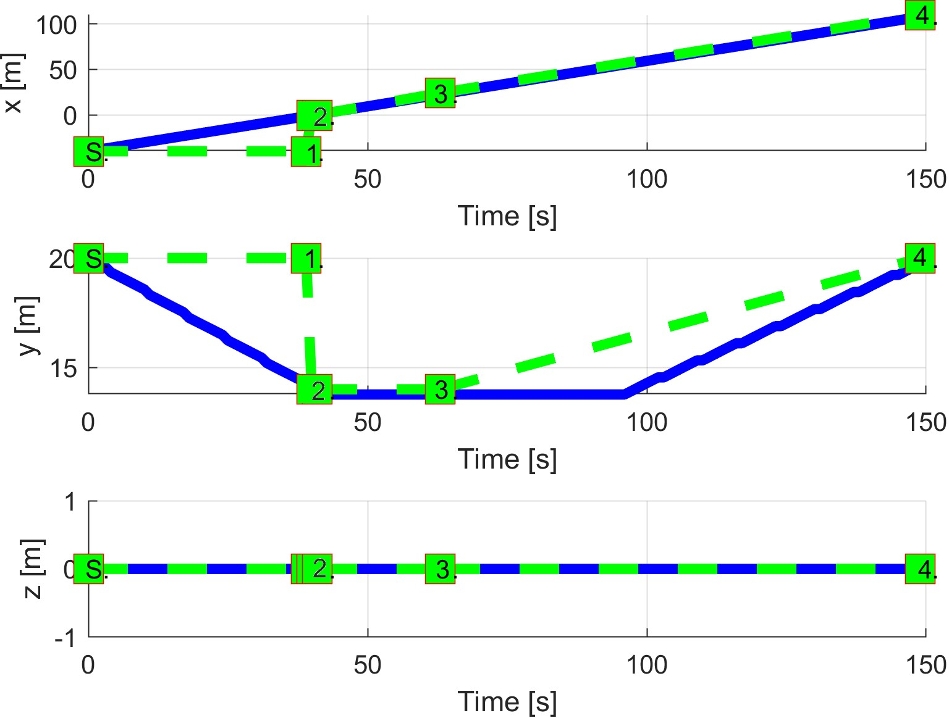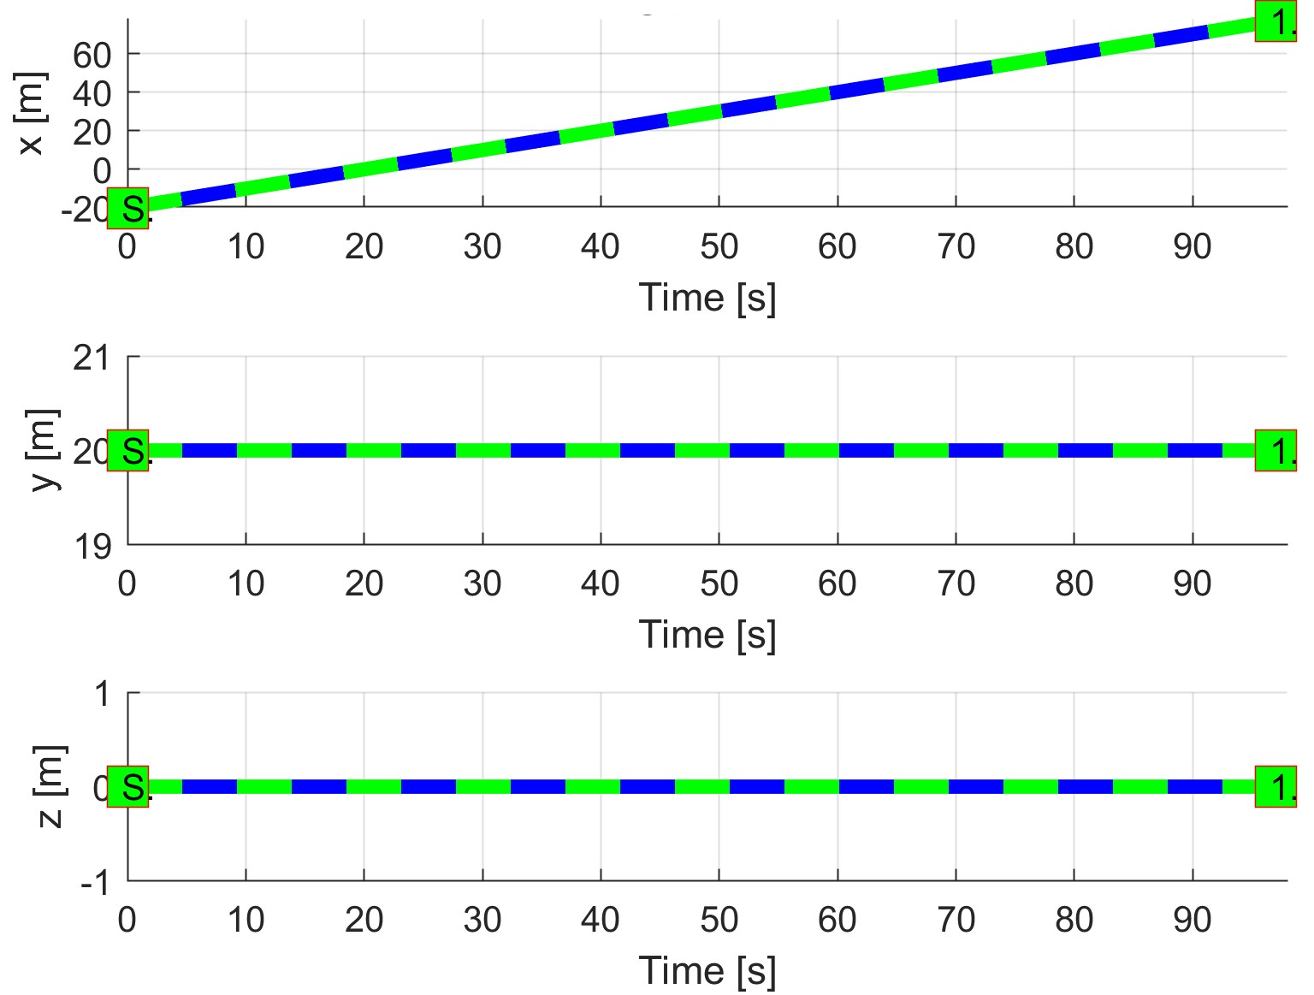

(a) UAS 1. (b) UAS 2.

Figure 7.16: Trajectory tracking for *Rule-based overtake double speed* situation test case.

**Path Tracking Deviations: 2x Speed** Path tracking deviations (tab. 7.17) are interesting for an *Overtake Maneuver* performance.

*Maximal deviation distance* is for important waypoints: Divergence (WP 2.), Convergence (WP 3.) and Original Goal Waypoint (WP 4.), equal to 0 *m*. This is the *desired effect* for *Overtake maneuver*.

*Collision point* (WP 1.) is avoided at minimal distance 5*.*7991 *m* (tab. 7.16) and maximal distance 24*.*5 *m* (tab. 7.17).

Other *Speed Difference Ratios* yields similar results.

|  |  |  |  |  |  |
| --- | --- | --- | --- | --- | --- |
| Param. |  | UAS 1 | |  | UAS 2 |
| WP1 | WP2 | WP3 | WP4 | WP1 |
| col. | div. | conv. | orig. | nav. |
| max|*x*| | 20 | 0 | 0 | 0 | 0 |
| max|*y*| | 6 | 0 | 4 | 5 | 0 |
| max|*z*| | 0 | 0 | 0 | 0 | 0 |
| max*dist.* | 24.5 | 0 | 4 | 5 | 0 |

Table 7.17: Path tracking properties for *Rule overtake 2x speed* scenario.

**Computation Load:** The *computation load* for *scenario* (fig.7.17) shows used time (y-axis) over decision frame (x-axis).

The load is minimal on both UAS because the rule calculates the only divergence (eq.

**??**) and convergence (eq. **??**) waypoints.

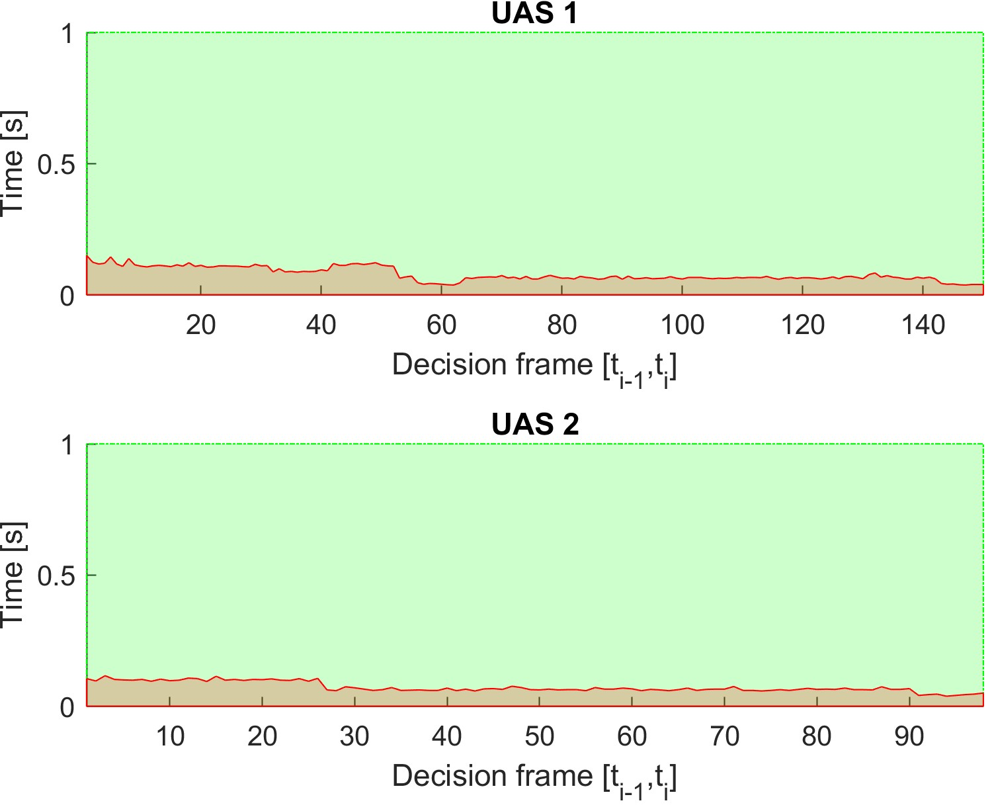

Figure 7.17: Computation time for *Rule-based overtake* scenario.